AI-Driven Forecasting of Reservoir Surface Water Dynamics Using Multi-Sensor Earth Observation, Climate Variables, and Machine Learning: A Case Study of Gurara Reservoir, Nigeria

[AUTHOR NAME(S)]
[AFFILIATION(S)]
[CORRESPONDING AUTHOR EMAIL]
[ORCID ID(S)]

Target Journal: [TARGET JOURNAL OR CONFERENCE]

Alternative Title Options:
1. Satellite-Derived Surface-Water Monitoring and Climate-Conditioned Forecasting of Gurara Reservoir, Nigeria, 2001-2030
2. Integrating Multi-Sensor Earth Observation and Explainable Machine Learning for Reservoir Surface Water Area Forecasting: Evidence from Nigeria's Gurara Reservoir
3. From Landsat Archive to 2030 Scenarios: A Multi-Model AI Framework for Monitoring and Projecting Surface Water Dynamics at Gurara Reservoir, Nigeria

Highlights
• A 304-month Landsat record (January 2001-April 2026) documents a statistically significant increase in visible surface-water area (Mann-Kendall tau = 0.431; Sen slope = 1.817 km2/year), dominated by reservoir formation and filling rather than a climate-only signal.
• MNDWI-based cross-sensor harmonisation across Landsat 5/7/8/9 and Sentinel-2 yields a correlation of 0.540 (MAE = 3.463 km²; bias = −0.967 km²), demonstrating moderate inter-sensor consistency with residual uncertainties that must be acknowledged in operational use.
• Among five evaluated models, SARIMA achieves the lowest short-horizon RMSE (1-month: 8.014 km²; 3-month: 9.648 km²), outperforming Random Forest, XGBoost, and persistence baselines on the sparse 196-observation time series, underscoring the risk of overfitting with high-complexity learners on limited hydroclimatic records.
• CMIP6 NEX-GDDP multi-model ensemble scenarios project median reservoir surface area approaching or reaching the active footprint ceiling (~55.84 km²) by December 2030 under central and wet conditions, with 95% prediction intervals widening substantially beyond 12 months, indicating low confidence in individual monthly projections at long horizons.
• The integrated decision-support framework—spanning satellite preprocessing, multi-index water detection, chronological model evaluation, bias-corrected climate projection, and spatial extent visualisation—provides a transferable blueprint for data-scarce reservoir monitoring in sub-Saharan Africa.

Abstract
Background: Reliable monitoring and forecasting of reservoir surface water dynamics are essential for water-resource management in data-scarce regions of sub-Saharan Africa, yet in-situ records at many storage facilities—including Gurara Reservoir, Nigeria—remain fragmentary or inaccessible.

Objective: This study develops and evaluates an end-to-end framework integrating multi-sensor Earth Observation, observed climate variables, statistical forecasting, machine learning, and CMIP6 scenarios to monitor and project the satellite-visible surface-water area of Gurara Reservoir from 2001 to 2030.

Data and Methods: A 304-month Landsat 5/7/8/9 record from January 2001 to April 2026 was processed to compute NDWI, MNDWI, and AWEI-nsh; MNDWI was retained following Landsat-Sentinel-2 cross-sensor assessment. CHIRPS rainfall and TerraClimate precipitation, temperature, actual evapotranspiration, potential evapotranspiration, and PDSI were integrated at monthly scale. Persistence, seasonal persistence, SARIMA, Random Forest, and XGBoost were evaluated using chronological training through 2018, validation during 2019-2021, and testing from 2022 onward. A fixed SARIMA(1,1,1)(1,1,1,12) operational model and a Ridge climate-response model driven by five bias-corrected NEX-GDDP-CMIP6 models under SSP2-4.5 and SSP5-8.5 generated scenarios through December 2030.

Principal Findings: Of 304 potential monthly Landsat observations, 196 (64.5%) passed quality control, with a 35.5% missing fraction and a longest contiguous valid run of 23 months. The April 2026 observed area of 36.808 km² exceeded the historical April mean (27.285 km²) by +9.522 km² (+34.9%). A highly significant positive long-term trend was detected (Mann-Kendall τ = 0.431; p = 3.19 × 10⁻¹⁹; Sen slope = 1.817 km²/year), attributable largely to progressive reservoir filling. SARIMA produced the lowest short-horizon RMSE (1-month: 8.014 km²; 3-month: 9.648 km²). The May 2026 operational SARIMA forecast is 41.890 km² (95% CI: 29.449–54.331 km²); April 2027 is 40.936 km² (95% CI: 19.735–55.837 km²). Under central CMIP6 conditions, the December 2030 median projected area is 55.84 km² (95% CI: 17.69–55.84 km²).

Conclusions and Implications: The framework demonstrates that multi-sensor EO archives can characterise reservoir surface water dynamics in data-scarce environments with moderate but transparent uncertainty. Short-horizon SARIMA forecasts provide operationally useful guidance for seasonal planning, while long-range CMIP6 scenarios carry low confidence beyond 12 months and should inform strategic contingency planning rather than precise operational decisions. Key limitations include the absence of water-level gauges, bathymetric surveys, abstraction records, and inflow data, which preclude storage estimation. Sentinel-1 radar integration, catchment-scale hydrological modelling, and bathymetry acquisition are recommended as priority next steps.

Keywords: reservoir surface water monitoring; Landsat time series; MNDWI; SARIMA forecasting; CMIP6 scenarios; machine learning hydrology; Gurara Reservoir; sub-Saharan Africa water security; explainable AI; Earth Observation

1. Introduction

1.1 Global Importance of Reservoir Monitoring
Reservoirs are critical infrastructure elements of the global hydrological cycle, providing freshwater for municipal supply, irrigation, hydropower generation, and flood regulation [Biemans et al., 2011; Hanasaki et al., 2006]. As global freshwater demand continues to rise under population growth, economic development, and climate change, the capacity to monitor reservoir states in near-real time and to forecast future dynamics has become a strategic necessity [Vörösmarty et al., 2010; Schewe et al., 2014]. Yet despite the centrality of reservoirs to human water security, systematic, long-term monitoring programs remain sparse across much of the Global South, where the combination of data scarcity, limited institutional capacity, and financial constraints has historically constrained evidence-based water management [Biemans et al., 2019; Falkenmark and Rockström, 2004].

1.2 African and Nigerian Water Security Context
Sub-Saharan Africa faces a particularly acute convergence of water-security challenges. The region hosts 17% of the world's population but controls only about 9% of global renewable freshwater resources, and storage infrastructure per capita is far lower than in comparable regions of Asia or Latin America [Grey and Sadoff, 2007; Seckler et al., 1999]. In Nigeria, the most populous country in Africa, reservoir infrastructure underpins municipal water supply for major urban centres, supports large-scale irrigation schemes, and provides hydroelectric generation. Gurara Reservoir in Kaduna State is a pivotal example: constructed to augment water supply to Abuja, the Federal Capital Territory, it represents a strategically vital national asset whose operational status has direct consequences for millions of people [Muhammed et al., 2015; Oguntunde et al., 2011].
Despite this significance, hydrological data records for Gurara Reservoir—including reservoir level, storage volume, inflow, and release records—are fragmentary, irregularly published, and rarely accessible to independent researchers [Oseke et al., 2021; Abubakar, 2014]. This data gap severely impedes evidence-based operation, drought preparedness, and long-term planning. Remote sensing offers a transformative opportunity to bridge this deficit, providing systematic, spatially explicit, and temporally consistent observations of reservoir surface water extent from archive records extending back to the early 1970s [Pekel et al., 2016; Schwatke et al., 2019].

1.3 Earth Observation and AI Opportunities
The emergence of cloud-computing platforms such as Google Earth Engine (GEE) [Gorelick et al., 2017], combined with the free and open Landsat archive [Wulder et al., 2022] and the high spatial resolution Sentinel-2 programme [Drusch et al., 2012], has fundamentally altered the feasibility of long-term reservoir monitoring in data-scarce regions. The Joint Research Centre (JRC) Global Surface Water product [Pekel et al., 2016] demonstrated that Landsat observations could be systematically converted into continental-scale surface water dynamics maps extending over three decades, transforming reservoir monitoring from a site-specific manual task into a scalable, semi-automated workflow.
Concurrently, advances in machine learning (ML) and artificial intelligence (AI)—including ensemble methods such as Random Forest [Breiman, 2001] and gradient boosting [Chen and Guestrin, 2016], recurrent neural architectures such as LSTM [Hochreiter and Schmidhuber, 1997], and statistical time-series models such as SARIMA [Box et al., 2015]—have created a rich methodological toolkit for hydrological forecasting. Nevertheless, applying sophisticated AI methods to sparse, irregularly observed reservoir time series in data-scarce settings requires careful design, honest evaluation, and robust uncertainty quantification to avoid misleading operational conclusions [Shen, 2018; Nearing et al., 2021].

1.4 Research Gap
Prior work documented Gurara Reservoir formation, catchment hydrology, and climate-response questions, but did not provide the same quality-controlled monthly 2001-2026 surface-area record, chronological comparison of statistical and machine-learning forecasts, and uncertainty-aware climate-conditioned scenarios through 2030. The present contribution is the integration and transparent evaluation of these components rather than a claim that the underlying methods are individually novel.

1.5 Aim, Objectives, and Research Questions
The overarching aim of this research is to develop, evaluate, and demonstrate an end-to-end AI-driven framework for monitoring and forecasting the satellite-visible surface water area of Gurara Reservoir using multi-sensor EO archives, hydroclimatic drivers, and statistical and ML models.
The specific objectives are:
O1. To construct a quality-controlled monthly surface-water area time series for Gurara Reservoir from January 2001 to April 2026 using Landsat 5/7/8/9 MNDWI composites.
O2. To assess cross-sensor consistency between Landsat-derived and Sentinel-2-derived MNDWI water areas over the period of temporal overlap.
O3. To characterise historical seasonality, inter-annual variability, and long-term trend in reservoir surface water area.
O4. To evaluate the forecasting skill of persistence baselines, SARIMA, Random Forest, and XGBoost models using chronologically rigorous validation protocols.
O5. To generate and communicate monthly operational forecasts for May 2026–April 2027 with explicit prediction intervals.
O6. To develop and evaluate CMIP6-driven climate-conditioned surface water area scenarios through December 2030 under central, dry, and wet pathway assumptions.
O7. To propagate forecast uncertainty spatially and produce decision-support visualisations of plausible reservoir extents.

The corresponding research questions are: (RQ1) What is the long-term trajectory of surface water area at Gurara Reservoir, and how does recent observed area compare with historical baselines? (RQ2) How well do MNDWI-derived Landsat observations agree with Sentinel-2 estimates? (RQ3) Which forecasting model achieves the best short-horizon predictive skill given the constraints of the available time series? (RQ4) What do CMIP6 climate projections imply for future reservoir surface water area trajectories, and how uncertain are these projections?

1.6 Research Hypotheses and Evidence Status
H1 proposed that climate variables would significantly improve surface-area forecasting over historical-area-only models. The current evidence is inconclusive: climate variables support scenario conditioning, but the tested climate-informed tree models did not consistently outperform the statistical and persistence benchmarks. No formal significance test establishes H1.
H2 proposed that advanced machine-learning, deep-learning, hybrid, and Transformer models would outperform traditional statistical models. The current results do not support H2: SARIMA led at 1 and 3 months, persistence-based methods led at 6 and 12 months, and deep sequence models were scientifically deferred because of data sparsity and discontinuity.

1.6 Contributions
This study makes the following contributions:
C1. A quality-controlled monthly MNDWI-based surface-water area time series for Gurara Reservoir covering January 2001-April 2026, with explicit missing-data accounting.
C2. A rigorous cross-sensor harmonisation assessment of Landsat and Sentinel-2 MNDWI water areas with quantified bias and MAE statistics.
C3. A comparative evaluation of five forecasting models under chronological validation protocols on a sparse and seasonally structured time series, with critical assessment of model complexity versus data availability.
C4. CMIP6-driven monthly surface water area scenarios for 2026–2030 with Monte Carlo uncertainty envelopes, explicitly distinguished from operational forecasts.
C5. A spatial decision-support framework that translates projected surface area statistics into plausible reservoir extent maps using historical water-persistence masks.
C6. A replicable, open-data workflow with explicit scientific safeguards and limitations that is transferable to other data-scarce reservoir systems in sub-Saharan Africa and beyond.

2. Literature Review

2.1 Reservoir Monitoring in Data-Scarce Regions
Monitoring reservoir dynamics is especially difficult where gauge networks and operational records are incomplete [Hughes, 2019]. Satellite archives provide repeatable observations of surface-water extent [Pekel et al., 2016; Donchyts et al., 2016], while small water bodies and reservoirs also carry substantial ecosystem and policy importance [Biggs et al., 2017]. These observations do not replace water-level, inflow, release, abstraction, or storage measurements needed for operational simulation.
Remote sensing has progressively filled some of these gaps. Satellite altimetry—including TOPEX/Poseidon, Envisat, ICESat, CryoSat-2, and, most recently, the Surface Water and Ocean Topography (SWOT) mission [Biancamaria et al., 2016; Biancamaria et al., 2010]—has been used to estimate reservoir surface elevations for hundreds of lakes and reservoirs globally [Crétaux et al., 2011; Schwatke et al., 2019]. Combining altimetry-derived elevation with satellite-derived surface area enables construction of area-elevation-volume (AEV) relationships, yielding storage estimates without in-situ gauges [Gao et al., 2012; Duan and Bastiaanssen, 2013]. However, these approaches require orbit pass frequencies that preclude monthly estimation at many reservoir locations, and AEV approaches require adequate knowledge of reservoir bathymetry [Busker et al., 2019; Crétaux et al., 2015]. For Gurara Reservoir, neither a validated bathymetric survey nor a reliable elevation-area curve is publicly available, precluding storage estimation and restricting the scope of the present study to surface water area monitoring.

2.2 Water Security and Reservoir Management in Sub-Saharan Africa
Sub-Saharan Africa is home to some of the world's most water-stressed catchments, with high inter-annual rainfall variability, rapidly growing urban populations, and infrastructure deficits that compound supply risks [Vörösmarty et al., 2010; Schewe et al., 2014]. Studies by [Hughes, 2019] and [Falkenmark and Rockström, 2004] highlight how reservoir storage capacity is often the principal buffer between demand and drought-induced supply failure across the Sahel and Guinea Savanna zones. In Nigeria, [Oguntunde et al., 2011] demonstrated significant drying trends in the Volta and Niger basins, while [Abubakar, 2014] documented the vulnerability of northern Nigerian water supplies to seasonal variability. [Muhammed et al., 2015] specifically noted that Gurara Reservoir's role in Abuja's water supply makes its monitoring a matter of national strategic importance.
Despite this importance, published hydrological and operational data for Gurara remain limited. [Oseke et al., 2021] modelled climate-change impacts and hydrological response in the approximately 2,150 km2 Gurara catchment using WEAP, demonstrating the value of catchment and climate modelling while also showing the additional information required for storage and inflow simulation. The present study complements that work with satellite-visible reservoir-area monitoring and forecasting; it does not replace a calibrated catchment or operations model.

2.3 Landsat-Based Long-Term Inland Water Monitoring
The Landsat programme, which has provided continuous multispectral imagery since 1972 [Wulder et al., 2022; Cohen and Goward, 2004], constitutes the foundation of long-term satellite-derived surface water monitoring. The combination of 30-metre spatial resolution, 16-day revisit cycle, and free public data access makes Landsat uniquely suited to detecting seasonal and inter-annual water extent dynamics at reservoirs and lakes of moderate to large size [Ji et al., 2009; Mueller et al., 2016]. [Pekel et al., 2016] harnessed the full Landsat archive from 1984 to 2015 to produce the JRC Global Surface Water (GSW) dataset, which maps surface water occurrence, recurrence, seasonality, and change at 30-metre resolution globally. This dataset has been updated regularly through the early 2020s and serves as the authoritative benchmark for long-term inland water mapping at continental to global scales [Pickens et al., 2020].
Long-term Landsat monitoring studies have been applied to large African lakes, including Lake Chad—which shrank by approximately 90% between 1963 and the 1990s before partial recovery [Lemoalle et al., 2012; Gao et al., 2011]—and reservoirs across the Nile basin, highlighting the value of the archive for characterising multi-decadal dynamics that cannot be captured by shorter EO records. However, Landsat monitoring is constrained by cloud cover—particularly acute during wet-season months in equatorial and sub-humid tropical regions—and by the Landsat 7 Scan Line Corrector (SLC-off) failure after 2003, which introduced striped data gaps affecting approximately 22% of each scene [Markham et al., 2004; Storey et al., 2005].

2.4 Sentinel-2 Reservoir and Lake Monitoring
The Sentinel-2 mission [Drusch et al., 2012], jointly operated by the European Space Agency (ESA) and the European Commission under the Copernicus programme [Aschbacher and Milagro-Pérez, 2012], provides 10–60 metre multispectral imagery at a 5-day revisit cycle with twin satellites (Sentinel-2A, launched 2015; Sentinel-2B, launched 2017). The higher spatial resolution and more frequent revisit compared with Landsat make Sentinel-2 particularly valuable for monitoring smaller water bodies and for detecting rapid area changes. [Goffi et al., 2020] compared Landsat 8 and Sentinel-2 for lake monitoring and found that Sentinel-2 achieved consistently higher accuracy at bodies with complex shorelines and significant wave action, though both sensors showed comparable performance for larger, geometrically simpler reservoirs.
Cross-sensor calibration between Landsat and Sentinel-2 is an active research area. [Li and Roy, 2017] developed spectral bandpass adjustment factors for the Operational Land Imager (OLI) on Landsat 8 and the MultiSpectral Instrument (MSI) on Sentinel-2A, finding that top-of-atmosphere reflectances differed by up to 8% in certain bands. For water index applications, [Roy et al., 2016] demonstrated that harmonised Landsat–Sentinel-2 (HLS) products could reduce inter-sensor area estimation discrepancies significantly, though residual uncertainties remained. For Gurara Reservoir, the 73-month overlap period between available Landsat and Sentinel-2 observations yielded a cross-sensor MNDWI correlation of 0.540 and a mean absolute error of 3.463 km², indicating moderate consistency with a systematic Landsat underestimation bias of −0.967 km².

2.5 Water Indices, Thresholding, and Water Segmentation
Several spectral water indices exploit the strong absorption of liquid water in near-infrared and shortwave-infrared wavelengths. NDWI uses green and NIR reflectance [McFeeters, 1996], MNDWI substitutes SWIR1 for NIR [Xu, 2006], and AWEI-nsh combines green, NIR, SWIR1, and SWIR2 reflectance [Feyisa et al., 2014]. Broader comparisons and machine-learning alternatives demonstrate the continuing sensitivity of water extraction to sensor, threshold, and training data [Huang et al., 2018; Jiang et al., 2018; Acharya et al., 2016]. In this study, all three indices used a zero threshold, and MNDWI was retained because it produced the most stable Landsat-Sentinel-2 monthly agreement.
Threshold selection is a critical but often underappreciated step in binary water classification. The [Otsu, 1979] method and its adaptive variants are widely used for automatic threshold identification by minimising intra-class variance in bimodal pixel histograms. However, in monthly composite images with mixed water–non-water pixels or frequent cloud masking, the histogram may not be clearly bimodal, and fixed thresholds may outperform adaptive ones over long time series [Xu et al., 2020; Huang et al., 2018]. For the present study, MNDWI was selected over NDWI and AWEInsh based on its superior performance in cross-sensor overlap months, and a threshold of zero was applied based on established literature recommendations [Xu, 2006; Acharya et al., 2016].

2.6 Cloud Masking, Compositing, and Missing Observations
Cloud cover is the principal impediment to optical satellite-based reservoir monitoring in tropical and subtropical environments. Monthly compositing—typically using the median of all cloud-free pixels within a calendar month after application of sensor-specific quality assessment (QA) bands—mitigates cloud impacts but cannot fully eliminate them, particularly during the West African Monsoon season (June–September) when persistent cloud cover can render entire months unusable [Vermote et al., 2016; Foga et al., 2017]. [Zhu et al., 2015] developed the CFMask algorithm, integrated into Landsat Collection 2 surface reflectance products, which substantially improved cloud detection accuracy in tropical regions compared with earlier single-scene approaches.
Missing observations—months where cloud contamination or sensor outages prevent any valid composite—create irregular time series with gaps that challenge both statistical and machine learning approaches. For the Gurara time series, 108 of 304 months (35.5%) were classified as missing or failed quality control, with the longest contiguous valid run spanning only 23 months. This level of missing data is not unusual for tropical reservoirs [Ji et al., 2009; Mueller et al., 2016] but significantly constrains the size of training datasets available to data-hungry ML models, motivating the use of simpler, more parsimonious forecasting approaches.

2.7 Climate Variables and Hydroclimatic Associations
Understanding the climatic drivers of reservoir surface water dynamics requires characterisation of both direct forcing variables (rainfall, evapotranspiration) and large-scale hydroclimatic indicators (soil moisture, drought indices). CHIRPS (Climate Hazards Group InfraRed Precipitation with Station data) [Funk et al., 2015] provides daily rainfall estimates at 0.05° resolution from 1981 to present, combining satellite-based thermal infrared precipitation estimates with station gauge data. It has been widely applied for reservoir inflow estimation and drought monitoring across sub-Saharan Africa [Paredes-Trejo et al., 2017; Dembélé and Zwart, 2016]. TerraClimate [Abatzoglou et al., 2018] provides monthly global gridded climate and water balance variables at approximately 4 km resolution from 1958 to present, including soil moisture, actual evapotranspiration, Palmer Drought Severity Index (PDSI), and reference evapotranspiration, making it particularly suited for hydroclimatic regression modelling.
While correlations between reservoir area and climate variables are conceptually intuitive, [Lehner et al., 2011] and [Oki and Kanae, 2006] caution that reservoir area responses to rainfall are substantially mediated by catchment area, antecedent soil moisture, reservoir operating rules, and water abstractions—all of which are poorly known for Gurara. Temporal lags between catchment rainfall and reservoir storage accumulation further complicate contemporaneous correlations. PDSI, developed by [Palmer, 1965] and subsequently updated by [Wells et al., 2004], integrates temperature-driven evaporative demand with precipitation anomalies but was originally calibrated for mid-latitude conditions; its application to tropical West Africa requires care and should be treated as an indicative rather than mechanistic drought indicator [Dai, 2011].

2.8 CMIP6, NEX-GDDP, and Climate Projection Methods
The sixth phase of the Coupled Model Intercomparison Project (CMIP6) [Eyring et al., 2016] provides an ensemble of global climate model projections under multiple Shared Socioeconomic Pathway (SSP) scenarios [O'Neill et al., 2016], representing the state-of-the-art in long-term climate change simulation. For regional-scale water resource applications, the raw CMIP6 output must be statistically or dynamically downscaled and bias-corrected before use as hydrological forcing [Teutschbein and Seibert, 2012; Maraun et al., 2010]. NASA's NEX-GDDP-CMIP6 dataset [Thrasher et al., 2022] provides bias-corrected, spatially downscaled daily climate projections at 0.25° resolution for SSP2-4.5 and SSP5-8.5 pathways, derived from 35 CMIP6 models, making it widely used for regional water resource scenario analysis.
A critical consideration in applying CMIP6 projections to reservoir-area forecasting is the translation of regional climate anomalies into reservoir-scale hydrological responses. The residual uncertainty in CMIP6 projections—stemming from model structural differences, internal climate variability, and uncertain emissions trajectories—is substantial over decadal horizons [Hawkins and Sutton, 2009; Lehner et al., 2020]. For West Africa, the sign and magnitude of projected precipitation changes remain poorly constrained: CMIP6 models project precipitation changes over Nigeria ranging from slight drying to significant wetting, depending on season and model [Faye and Akinsanola, 2022; James et al., 2020]. This ensemble spread, explicitly represented in the 95% projection intervals reported in the present study, implies that long-range scenario projections should be treated as plausibility envelopes rather than precise predictions.

2.9 Statistical and Machine Learning Forecasting in Hydrology
Hydrological time series forecasting has been approached with methods spanning from simple seasonal persistence benchmarks to deep learning architectures. ARIMA and SARIMA models [Box et al., 2015] capture temporal autocorrelation and seasonality in stationary or transformed series and have been widely applied to monthly streamflow and reservoir level forecasting [Kisi and Cimen, 2011; Valipour et al., 2013]. Their parsimony, interpretability, and robustness on short time series make them natural baselines for comparison with more complex ML methods [Makridakis et al., 2018].
Separate direct Random Forest and XGBoost regressors were fitted for each 1-, 3-, 6-, and 12-month target horizon using the engineered feature matrix. Target dates, rather than predictor dates, defined the chronological split. The models were not recursively iterated using their own predictions. Permutation and built-in importance were saved as diagnostics. The design was informed by broader machine-learning and Random Forest hydrology literature [Raghavendra and Deka, 2014; Shortridge et al., 2016; Tyralis et al., 2019; Park et al., 2015].
Long short-term memory (LSTM) networks [Hochreiter and Schmidhuber, 1997] and gated recurrent units (GRU) [Cho et al., 2014] have achieved state-of-the-art performance on multi-year streamflow benchmarks [Kratzert et al., 2018; Nearing et al., 2021]. The Temporal Fusion Transformer (TFT) [Lim et al., 2021] further combines multi-horizon forecasting with interpretable attention mechanisms. However, these architectures require substantial training data—typically hundreds to thousands of monthly observations—to avoid degenerate solutions. For Gurara, with 196 valid monthly observations and a requirement for chronological train-test splitting, these architectures were assessed as likely to underperform more parsimonious alternatives and were not implemented in the current study, consistent with the recommendation of [Shen, 2018] that model complexity should be matched to data availability.

2.10 Chronological Validation, Evaluation Metrics, and Explainability
A persistent methodological challenge in ML-based hydrological forecasting is data leakage: the accidental use of future information during model training or selection, which produces misleadingly optimistic validation metrics [Feng et al., 2020; Chatfield, 2000]. Chronological splitting—where the training period always precedes the validation and test periods in calendar time—is a minimum requirement for valid hydrological forecast evaluation [Kratzert et al., 2018; Makridakis et al., 2018]. Rolling-origin cross-validation [Bergmeir and Benítez, 2012] further improves robustness by systematically expanding the training window, at the cost of increased computational expense.
Standard evaluation metrics for hydrological forecasting include RMSE, MAE, mean absolute percentage error (MAPE), coefficient of determination (R²), Nash-Sutcliffe Efficiency (NSE) [Nash and Sutcliffe, 1970], and Kling-Gupta Efficiency (KGE) [Gupta et al., 2009]. NSE is particularly informative because negative values indicate that the model performs worse than the mean of the observations—a threshold that all legitimate forecasting models should surpass for operationally meaningful predictions. The persistence and seasonal persistence baselines used here define the minimum acceptable performance bar.
Explainability tools such as SHAP, partial-dependence analysis, and permutation importance can help diagnose machine-learning models [Lundberg and Lee, 2017; Li and Razavi, 2024]. The implemented Gurara workflow reports permutation and built-in tree-model importance only; SHAP and attention-based interpretations were not completed and are not claimed.

2.11 Synthesis Table of Representative Studies

Study | Location | Data | Period | Method | Horizon | Validation | Key Result | Limitation | Relevance to Gurara
[Pekel et al., 2016] | Global | Landsat | 1984–2015 | JRC GSW classification | N/A | Reference dataset | 3 million km² water mapped | No volume estimation | Foundation dataset used
Schwatke et al. [2019] | Global lakes/reservoirs | Landsat + Sentinel-2 | Multi-year | Automated water-surface extraction | N/A | Cross-sensor/application checks | Consistent time-variable water surfaces | Optical cloud gaps | Supports multi-sensor area monitoring
[Gao et al., 2012] | 130 reservoirs, China | Landsat + MODIS | 2000–2011 | Area-volume regression | Seasonal | Field validation | Storage estimated remotely | Bathymetry required | Bathymetry unavailable at Gurara
[Busker et al., 2019] | 137 lakes globally | Landsat | 1984–2015 | JRC GSW area-elevation | N/A | Satellite altimetry | Area-volume relationships | Coarse for small lakes | Method requires altimetry
Oseke et al. [2021] | Gurara catchment, Nigeria | Climate + hydrological data | 1989-2019 | WEAP hydrological modelling | To 2050 | Calibration and validation metrics | Climate-conditioned catchment response | Requires operational/hydrological inputs | Gurara-specific climate-modelling precedent
[Muhammed et al., 2015] | Gurara, Nigeria | Field data | 2006–2013 | Descriptive statistics | N/A | In-situ | Supply-demand analysis | Short record, no RS | Contextualises demand
[Kratzert et al., 2018] | 241 basins, USA | MOPEX | 1999–2008 | LSTM | Daily | CAMELS benchmark | LSTM > SAC-SMA | Large training dataset | Data volume not available at Gurara
[Shortridge et al., 2016] | 3 African basins | CHIRPS, climate | 1981–2012 | Random Forest | Monthly | Cross-validation | RF competitive with SWAT | No uncertainty intervals | RF approach tested here
[Funk et al., 2015] | Africa, global | Satellite+gauge | 1981–present | CHIRPS product | N/A | Gauge comparison | Improved rainfall estimation | Bias in dense-forest zones | Primary rainfall data source
[Thrasher et al., 2022] | Global | CMIP6 models | 1950–2100 | NEX-GDDP downscaling | Decadal | Bias correction validation | 0.25° daily projections | Residual bias in tropics | CMIP6 forcing data source
[Valipour et al., 2013] | Iran reservoirs | Gauge data | 1980–2010 | ARIMA/SARIMA | 1–12 months | RMSE, R² | SARIMA effective seasonally | Stationary assumption | Supports SARIMA choice
[Makridakis et al., 2018] | M4 Competition | 3003 time series | Various | 23 methods compared | 1–18 months | Competition benchmark | Simple methods competitive | No spatial context | Justifies parsimonious models
[Faye and Akinsanola, 2022] | West Africa | CMIP6 | 1981–2100 | GCM ensemble analysis | Decadal | Observed rainfall | Uncertain precipitation trends | Large model spread | Context for CMIP6 uncertainty

2.12 Identified Research Gap
The foregoing synthesis reveals that while global and continental-scale tools for reservoir monitoring and climate projection are well established, their integration into a coherent, site-specific forecasting and decision-support framework for a data-scarce African reservoir—with explicit uncertainty quantification, multi-model comparison, cross-sensor validation, and spatial output generation—has not been previously demonstrated for Gurara Reservoir. The present study does not claim methodological novelty solely on the basis that a given technique has not previously been applied at Gurara; rather, it contributes a systematic assembly and critical evaluation of state-of-the-art methods under data constraints that represent conditions faced by many reservoir monitoring programs across sub-Saharan Africa.

3. Study Area

3.1 Gurara Reservoir and Its Regional Role
Gurara Reservoir is an artificial impoundment in Kaduna State, north-central Nigeria, with regional importance for water-resource planning. The analysis is centred near 9.69 degrees N, 7.77 degrees E. Because continuous public operational records were unavailable, this study describes satellite-visible surface-water area rather than reservoir storage, level, release, or supply security.
The active recurring-water footprint covers 55.837 km2. It was derived from the JRC Global Surface Water occurrence band using a 20% occurrence threshold and selection of the connected polygon at the configured reservoir seed. It is a multi-year recurring-water envelope, distinct from the broader configured study rectangle and from the complete approximately 2,150 km2 catchment described in Gurara-specific hydrological literature.

3.2 Geographic Location and Physical Setting
The configured reservoir seed is approximately 9.69 degrees N, 7.77 degrees E, within a broader WGS84 study rectangle spanning 7.651291-7.849045 degrees E and 9.610762-9.907837 degrees N. The rectangle supports local extraction and context; it is not a substitute for a formally delineated catchment boundary.

3.3 Rainfall Seasonality and Environmental Context
Rainfall is strongly seasonal, with most precipitation occurring during the West African wet season and lower rainfall during the dry season. The observed surface-area record shows an April mean minimum and generally higher late wet-season and early dry-season values. Exact rainfall normals and operational drawdown behaviour require catchment and in-situ data beyond the present analysis.

3.4 Data Constraints
No publicly available continuous gauge records for Gurara Reservoir water level, storage volume, inflow, release, or abstraction were accessible for this study. The absence of these in-situ records means that the present analysis is restricted to satellite-visible surface water area and cannot provide estimates of total reservoir storage, water volume, or changes in bathymetric capacity due to sedimentation. Additionally, no independently validated bathymetric survey or area-elevation-volume relationship was available, precluding construction of a remote sensing-based storage proxy.

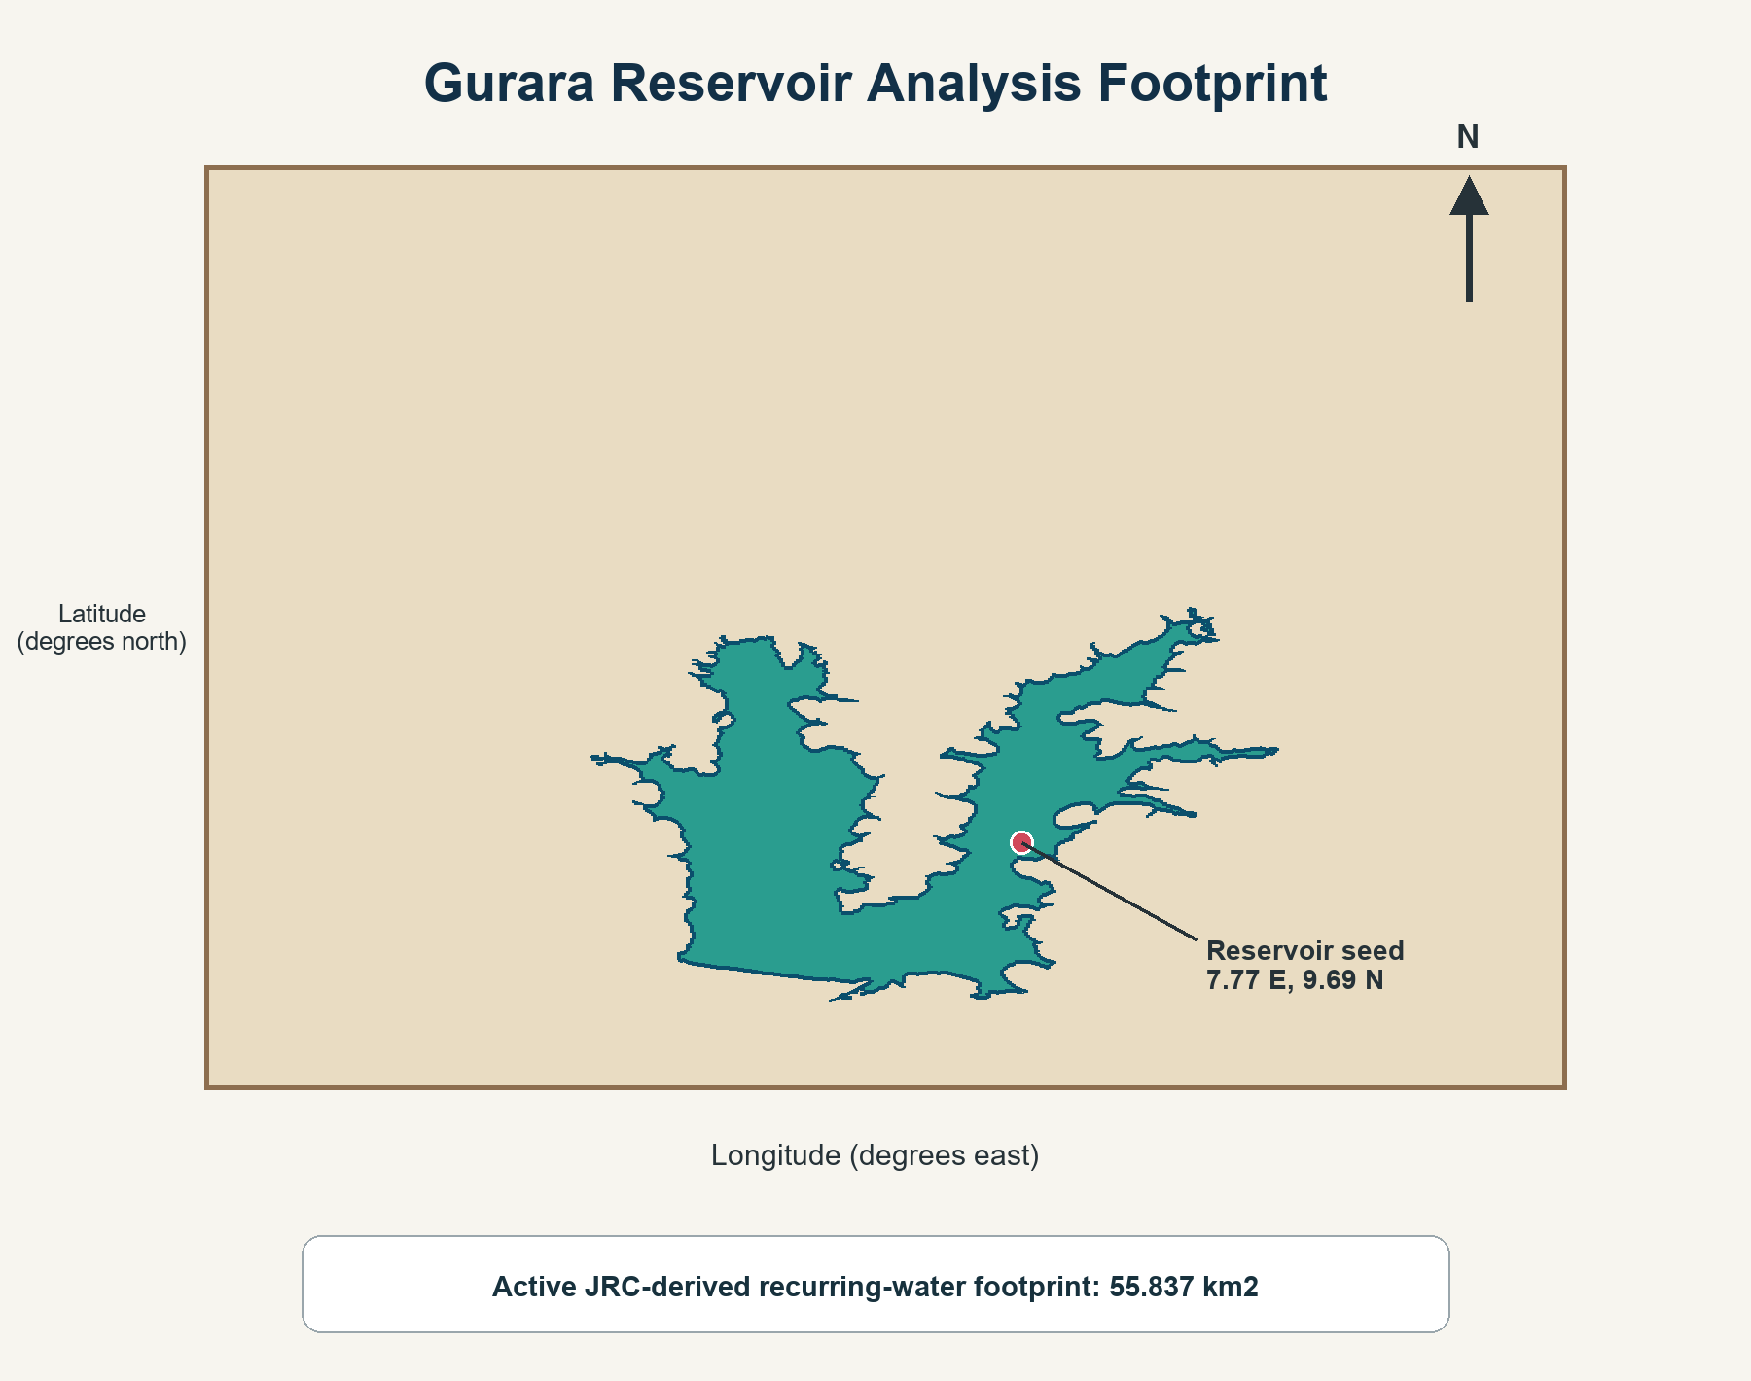
Figure 1. Gurara Reservoir active JRC-derived recurring-water footprint (55.837 km2), broader configured study rectangle, and reservoir seed location. The rectangle is a local analysis region, not the complete Gurara catchment. Source: project boundary and configuration files.

4. Data and Methods

4.1 Satellite Data Sources

4.1.1 Landsat 5/7/8/9
Landsat 5, 7, 8, and 9 Collection 2 Level-2 surface-reflectance images were processed in Google Earth Engine from January 2001 [Masek et al., 2006; USGS, 2022]. Green, NIR, SWIR1, and SWIR2 bands were harmonised across sensors and scaled using Collection 2 factors. Scenes were filtered by the study geometry, date, and a maximum scene cloud percentage of 80%.
Landsat QA_PIXEL bits were used to mask dilated cloud, cirrus, cloud, cloud shadow, and snow, while QA_RADSAT removed saturated pixels. Monthly median composites were created from the remaining observations. Landsat 7 SLC-off gaps were handled through the quality masks and monthly compositing rather than a separate gap-filling algorithm.

4.1.2 Sentinel-2
Sentinel-2 Level-2A surface reflectance was obtained from COPERNICUS/S2_SR_HARMONIZED in Google Earth Engine. The Scene Classification Layer excluded saturated/defective, cloud-shadow, unclassified, medium/high cloud, cirrus, and snow/ice classes (1, 3, 7, 8, 9, 10, and 11). Monthly median composites were generated from scaled green, NIR, SWIR1, and SWIR2 bands. Alternative cloud classifiers such as Hollstein's rules and s2cloudless are documented in the literature [Hollstein et al., 2016; Zupanc, 2017] but were not used in the implemented extraction.

4.1.3 JRC Global Surface Water
The JRC Global Surface Water v1.4 occurrence band at 30 m resolution was used to derive the active reservoir envelope. Pixels meeting the configured 20% occurrence threshold were vectorised, and the connected polygon at the reservoir seed was retained. The resulting 55.837 km2 envelope constrained all area estimates and forecast bounds; it is not a surveyed shoreline for one date.

4.1.4 Dynamic World Validation Context
The project includes an optional Google Dynamic World monthly water-probability workflow for threshold assessment. Dynamic World is itself satellite-derived and was not used as independent field ground truth. The final preferred MNDWI series was selected from Landsat-Sentinel-2 monthly agreement; no field-labelled validation dataset was available.

4.2 Hydroclimatic Data Sources

4.2.1 CHIRPS Rainfall
Monthly CHIRPS rainfall was summed from daily observations and spatially averaged over the configured study geometry. No 50-km catchment buffer was used. The same geometry was used to summarise the TerraClimate variables.

4.2.2 TerraClimate
TerraClimate supplied monthly precipitation, minimum, maximum, and mean temperature, actual evapotranspiration, potential evapotranspiration, and PDSI. Soil moisture was not included in the extracted or modelled dataset. TerraClimate scale factors were applied during extraction and checked during local preparation.

4.2.3 NEX-GDDP-CMIP6
Daily precipitation and minimum, maximum, and mean temperature were extracted from NASA NEX-GDDP-CMIP6 for five models (ACCESS-CM2, CNRM-CM6-1, EC-Earth3, MPI-ESM1-2-HR, and MRI-ESM2-0) under SSP2-4.5 and SSP5-8.5. The ten model-pathway members were aggregated monthly. Monthly 2001-2014 corrections used ratios for rainfall and PET and additive temperature adjustment against CHIRPS and TerraClimate observations. Quantile-delta mapping is an established alternative [Cannon et al., 2015] but was not implemented here.

4.3 Water Index Computation
Three spectral water indices were computed from monthly composite surface reflectance images:
NDWI = (ρ_{Green} − ρ_{NIR}) / (ρ_{Green} + ρ_{NIR}) (1)
MNDWI = (ρ_{Green} − ρ_{SWIR1}) / (ρ_{Green} + ρ_{SWIR1}) (2)
AWEInsh = 4(ρ_{Green} − ρ_{SWIR1}) − (0.25ρ_{NIR} + 2.75ρ_{SWIR2}) (3)
where ρ denotes surface reflectance in the subscripted spectral band. Pixels were classified as water where index value > 0 (for NDWI and MNDWI) and > 0 (for AWEInsh). For each monthly composite, total surface water area was computed by multiplying the count of water-classified pixels by the pixel area (900 m² for Landsat/Sentinel-2 at 30 m resolution), converting to km².
MNDWI was selected as the primary water indicator over NDWI and AWEInsh based on its superior cross-sensor correlation with Sentinel-2 during the 73 overlap months, consistent with established recommendations for reservoir applications with limited turbid or algal cover [Xu, 2006; Fisher et al., 2016].

4.4 Quality Control and Feature Engineering
A monthly water-area observation was retained when at least one image was available, valid pixel coverage was at least 0.50, and the preferred MNDWI area was non-missing. Failed months were retained as missing values. No median-plus-or-minus-three-IQR outlier filter was applied.
Features included current observed climate values, climate anomalies, month and year, cyclical month encoding, wet-season indicator, water-area lags at 1, 2, 3, 6, and 12 months, rainfall lags at 1, 3, and 6 months, and 3-, 6-, and 12-month rolling area, rainfall, and temperature statistics. Random Forest and XGBoost used median imputation within their model pipelines; tree features were not standardised.

4.5 Forecasting Models

4.5.1 Persistence and Seasonal Persistence
For each forecast horizon h, persistence predicted the future target using the current observed area. Seasonal persistence used the observation shifted by 12-h months so that the predictor corresponds to the same calendar month in the previous year where available. Both were evaluated on the same chronological target periods as the trained models.

4.5.2 SARIMA
A fixed SARIMA(1,1,1)(1,1,1,12) model was used. The monthly series was interpolated for model fitting, the initial model was fitted through December 2018, and walk-forward h-step predictions were generated for 1-, 3-, 6-, and 12-month horizons. Each newly observed month was appended without refitting. Although AICc is commonly used for small-sample order selection [Hurvich and Tsai, 1989], no AIC or AICc order grid search was performed here.

4.5.3 Random Forest and XGBoost
Separate direct Random Forest and XGBoost regressors were fitted for each 1-, 3-, 6-, and 12-month target horizon using the engineered feature matrix. Target dates, rather than predictor dates, defined the chronological split. The models were not recursively iterated using their own predictions. Permutation and built-in importance were saved as diagnostics. The design was informed by broader machine-learning and Random Forest hydrology literature [Raghavendra and Deka, 2014; Shortridge et al., 2016; Tyralis et al., 2019; Park et al., 2015].

4.6 Validation Protocol and Metrics
All models used chronological target-date splits: training through December 2018, validation from January 2019 through December 2021, and testing from January 2022 through the latest available target. Random splitting was not used. RMSE, MAE, MAPE, R2/NSE, and KGE were calculated, with negative NSE interpreted as performance below the corresponding observed-mean benchmark.
RMSE = √(1/n · Σᵢ(ŷᵢ − yᵢ)²) (4)
Additional metrics included Mean Absolute Error (MAE = 1/n · Σ|ŷᵢ − yᵢ|), Nash-Sutcliffe Efficiency (NSE = 1 − Σ(yᵢ − ŷᵢ)² / Σ(yᵢ − ȳ)²) [Nash and Sutcliffe, 1970], and Kling-Gupta Efficiency (KGE = 1 − √(r−1)² + (σ̂/σ−1)² + (μ̂/μ−1)²) [Gupta et al., 2009], where r is the Pearson correlation between observed and simulated values, σ and σ̂ are observed and simulated standard deviations, and μ and μ̂ are observed and simulated means.

Potential evapotranspiration for CMIP6 members was estimated using the Hargreaves-Samani formulation [Hargreaves and Samani, 1985] from projected minimum, maximum, and mean temperature, then ratio-corrected to the observed TerraClimate PET monthly climatology.

4.7 Climate Scenario Generation

4.7.1 Ridge Climate-Response Model
A standardised Ridge model [Hoerl and Kennard, 1970] used previous area, 12-month area lag, 3-month rolling area, rainfall, 3-month rainfall sum, mean temperature, PET, and cyclical month indicators. Training began in 2008 after filling short internal gaps and yielded 208 rows, selected alpha 10.0, and time-series cross-validation RMSE of 6.798 km2. AET, PDSI, and soil moisture were not Ridge predictors.

4.7.2 Scenario Assumptions and Uncertainty Propagation
The projection combined a 56-month SARIMA baseline with climate-response adjustments from all ten CMIP6 model-pathway members. Central conditions used unmodified corrected climate; dry conditions applied rainfall x 0.85, PET x 1.10, and temperature +1.0 C; wet conditions applied rainfall x 1.15, PET x 0.95, and temperature -0.5 C. These are stress-test assumptions, not probabilities or CMIP6 percentiles. Five thousand Monte Carlo draws combined SARIMA standard error with member-to-member climate-adjustment spread, and results were clipped to 0-55.837 km2.

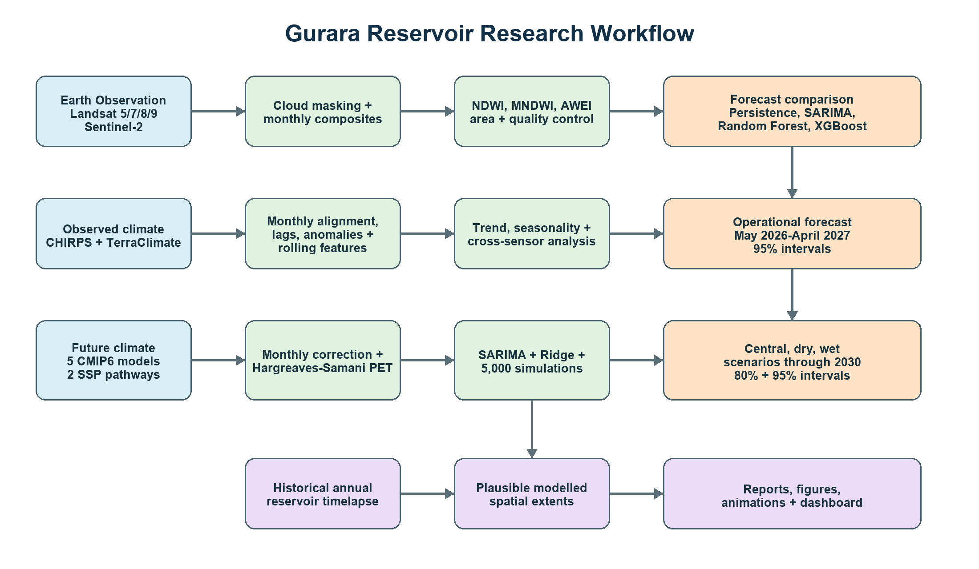
Figure 2. Research workflow integrating satellite preprocessing, water-index extraction, climate variables, time-series analysis, forecast evaluation, CMIP6 scenarios, uncertainty analysis, and spatial decision-support outputs. Arrows indicate data flow; blue boxes represent EO data streams; green boxes indicate modelling steps; orange boxes indicate output products. Source: Authors.

5. Results

5.1 Data Quality and Observation Availability
The analysis contained 304 monthly rows from January 2001 through April 2026. Of these, 196 months (64.5%) passed quality control and 108 months (35.5%) were missing or failed. The longest contiguous valid run was 23 months. The latest valid observation was April 2026. Missingness primarily reflects absent imagery or valid coverage below 50%; causal attribution to particular clouds, outages, or SLC gaps was not quantified month by month.

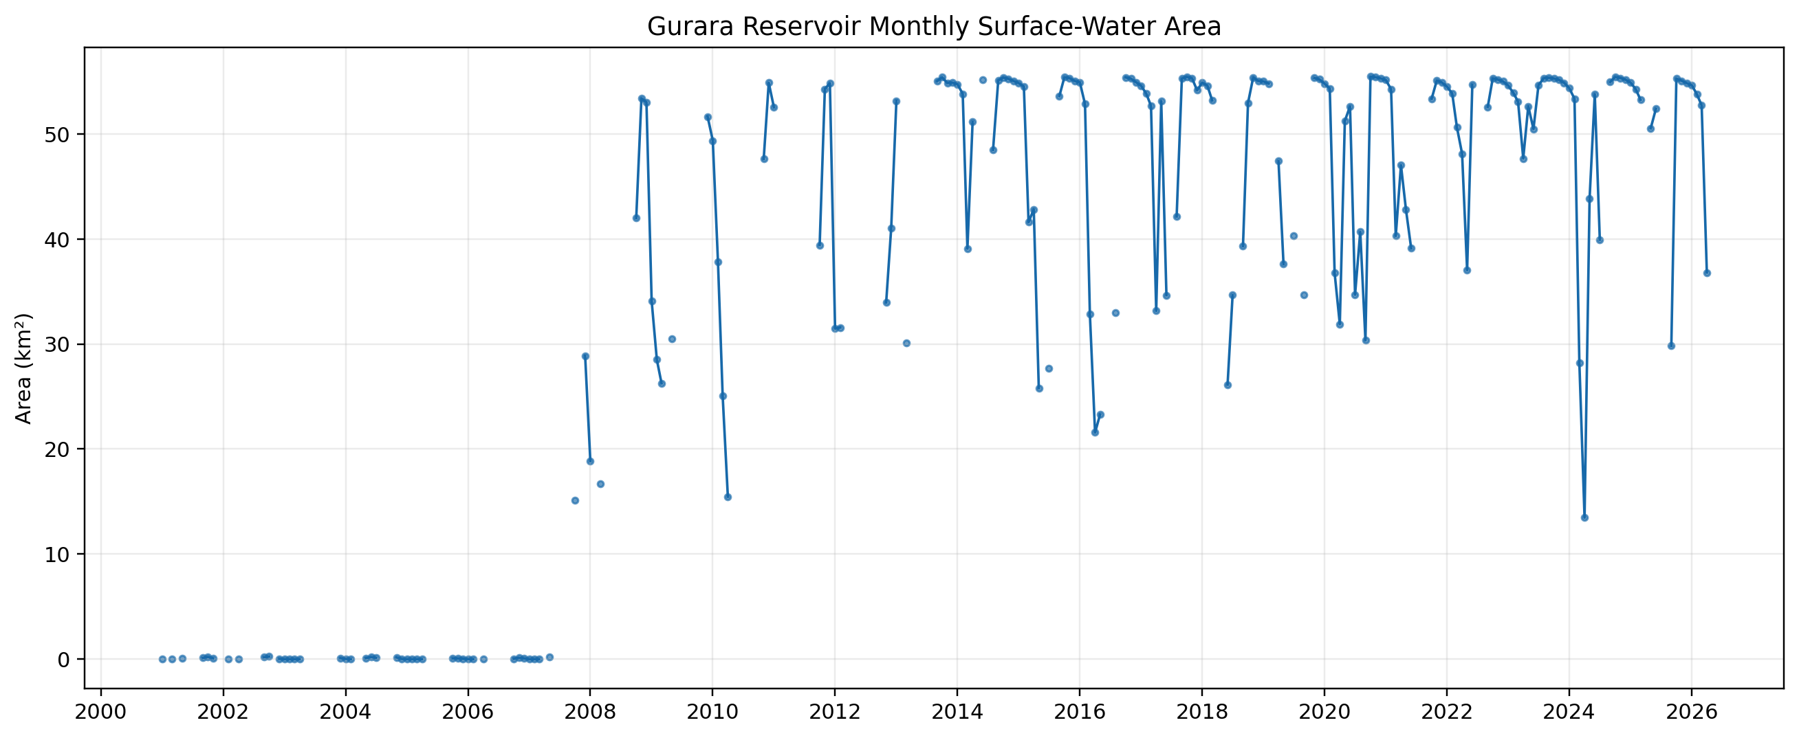
Figure 3. Quality-controlled monthly MNDWI-derived surface-water area of Gurara Reservoir, January 2001-April 2026. Missing periods reflect image availability and valid-coverage filtering. The early record includes reservoir formation and filling. Source: project output outputs/figures/01_monthly_water_area.png.

5.2 Cross-Sensor Water-Index Assessment
During the 73-month Landsat–Sentinel-2 overlap period, MNDWI-derived surface water areas from both sensors were compared. The Pearson correlation between Landsat and Sentinel-2 monthly estimates was 0.540. The mean absolute error was 3.463 km², and the systematic bias was −0.967 km² (Landsat underestimating relative to Sentinel-2). These statistics indicate moderate cross-sensor consistency; the MAE of approximately 3.5 km² represents about 6% of the active footprint, and the bias suggests a systematic tendency for Landsat composites to underestimate surface area relative to Sentinel-2, likely reflecting differences in spatial resolution (30 m versus 10 m for Sentinel-2 green band), overpass timing, and residual cloud contamination in monthly medians.
It is important to note that Sentinel-2 MNDWI agreement does not constitute field validation of absolute water area accuracy. Neither sensor has been independently validated against GPS-surveyed shoreline measurements at Gurara Reservoir, and the cross-sensor comparison quantifies inter-sensor consistency rather than absolute accuracy.

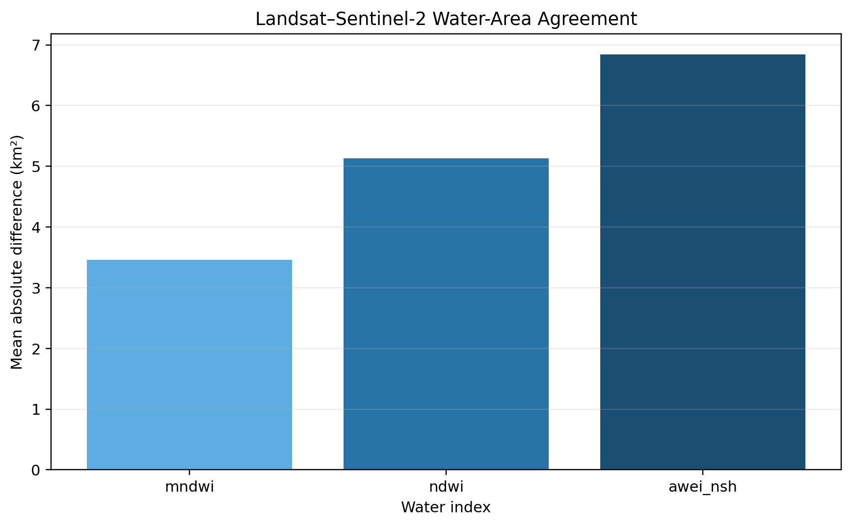
Figure 4. Cross-sensor comparison of MNDWI-derived surface water area from Landsat and Sentinel-2 over the 73-month overlap period. The 1:1 line is shown in grey; the regression fit is shown in blue. Statistics: Pearson r = 0.540, MAE = 3.463 km², bias = −0.967 km². Observed: derived from monthly composites of both sensors. Source: Authors; file outputs/figures/08_cross_sensor_validation.png.

5.3 Historical Surface Water Dynamics

5.3.1 Monthly Seasonality
The quality-controlled climatology shows the lowest mean area in April (27.285 km2) and the highest mean in August (43.908 km2). Late-year medians are also high, but monthly sample sizes differ because of quality filtering. The April 2026 area of 36.808 km2 was 9.522 km2 (34.9%) above the historical April mean.

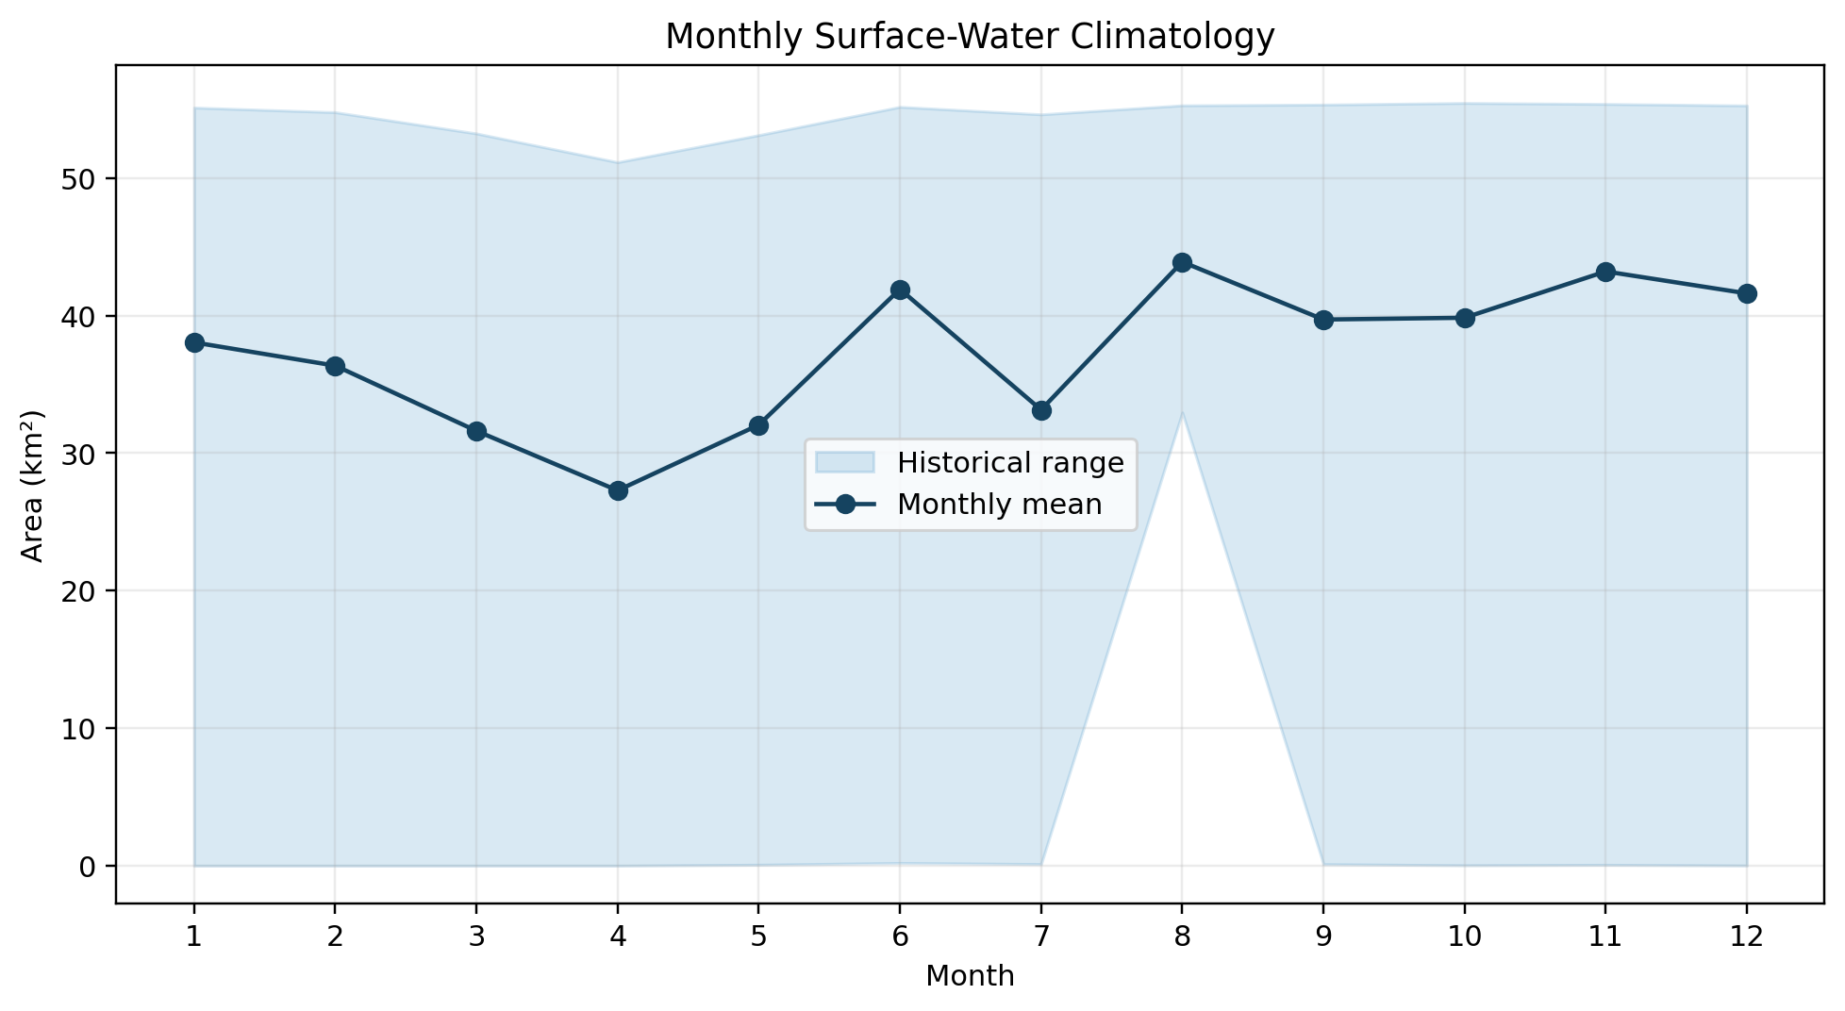
Figure 5. Monthly distribution and climatological mean of Landsat MNDWI-derived surface-water area, January 2001-April 2026. Monthly sample counts vary because of optical quality filtering. Source: outputs/figures/02_monthly_climatology.png.

5.3.2 Long-Term Trend
A Mann-Kendall test on 196 valid observations produced tau = 0.431 and p = 3.19 x 10^-19. The Sen slope was 1.817 km2/year. This monotonic trend spans the transition from little or no mapped reservoir water in the early record to a mature impoundment and therefore must not be interpreted as a climate-only effect.
Critical interpretation is essential: the positive trend includes reservoir formation and filling after 2001. Without inflow, release, abstraction, storage, and operational records, the relative influence of climate and management cannot be separated.

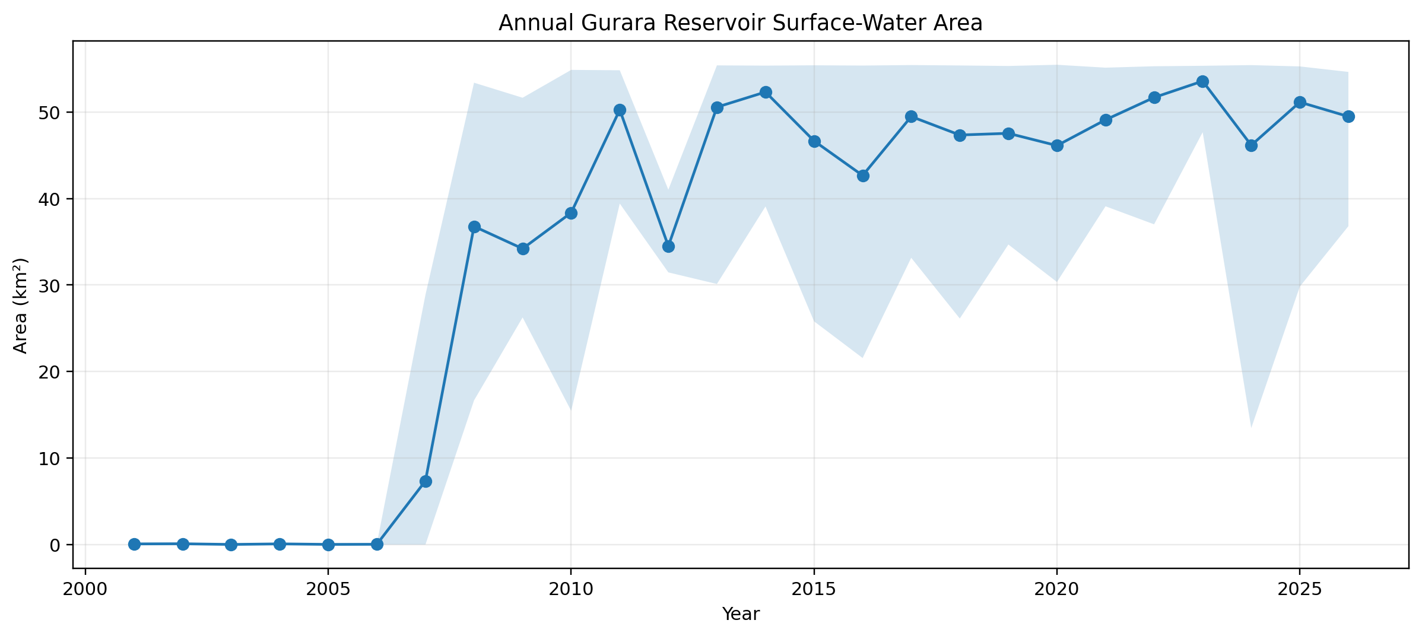
Figure 6. Annual mean, minimum, and maximum quality-controlled surface-water area from 2001 to 2026. Annual observation counts differ because of image availability and valid-coverage filtering. Source: outputs/figures/03_annual_water_area.png.

5.4 Climate Associations
Exploratory contemporaneous correlations were generally weak: CHIRPS rainfall r = 0.037, TerraClimate precipitation r = -0.036, mean temperature r = -0.144, AET r = 0.094, PET r = -0.045, and PDSI r = -0.454. These bivariate associations are not causal and are confounded by reservoir formation, seasonality, missingness, lagged catchment response, and unobserved operations.

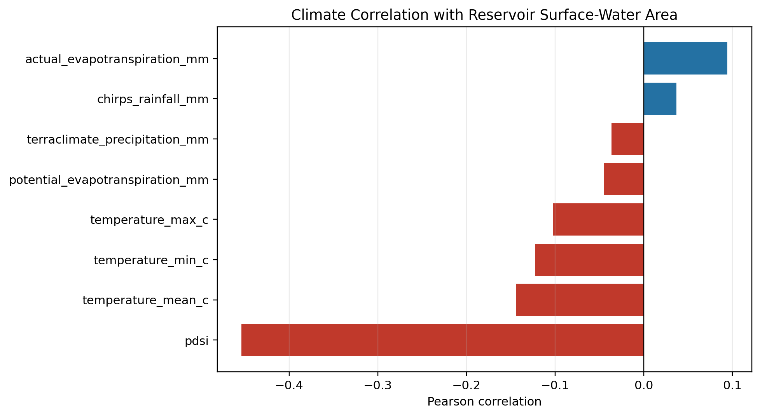
Figure 7. Contemporaneous Pearson correlations between quality-controlled monthly surface-water area and observed climate variables. The chart is exploratory and does not establish causation. Source: outputs/figures/04_climate_correlations.png.

5.5 Model Performance
Test-period rankings use targets from January 2022 onward. SARIMA had the lowest RMSE at 1 month (8.014 km2; NSE 0.075) and 3 months (9.648 km2; NSE -0.341). Seasonal persistence was selected at 6 months (RMSE 9.836 km2; NSE -0.292), and persistence was selected at 12 months with the same metrics. Negative longer-horizon NSE values indicate weak predictive skill relative to the observed-mean benchmark.

Selected model | Horizon | RMSE (km2) | MAE (km2) | NSE | KGE
SARIMA | 1 month | 8.014 | 5.393 | 0.075 | 0.516
SARIMA | 3 months | 9.648 | 7.011 | -0.341 | 0.317
Seasonal persistence | 6 months | 9.836 | 5.029 | -0.292 | 0.088
Persistence | 12 months | 9.836 | 5.029 | -0.292 | 0.088
Random Forest | 1 month | 9.643 | 7.382 | -0.267 | 0.380
XGBoost | 1 month | 9.500 | 6.789 | -0.229 | 0.410
Ridge climate model | Time-series CV | 6.798 | Not reported | Not reported | Not reported

Table 2. Selected model performance for the chronological test period beginning January 2022. Exact values are taken from outputs/models/comparison/best_models_by_horizon.csv.

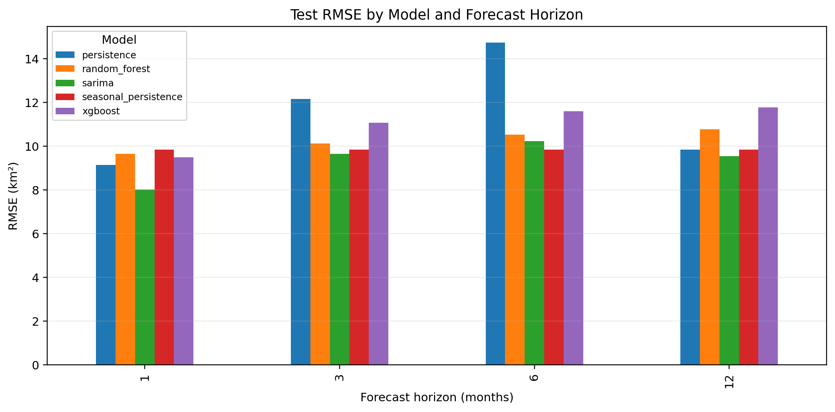
Figure 8. Comparative RMSE of all evaluated models at 1-, 3-, 6-, and 12-month forecast horizons on the chronological test set. Lower values indicate better performance. The seasonal persistence RMSE benchmark is shown as a horizontal dashed line. Derived: from chronological train-test evaluation. Source: Authors; file outputs/figures/05_model_rmse_comparison.png.

5.6 Explainability Diagnostics
Feature-importance diagnostics varied by horizon and model. For the 12-month Random Forest, minimum temperature, 3-month-lagged rainfall, and mean-temperature anomaly had the largest positive permutation scores, while area lags were smaller and several variables had near-zero or negative scores. Built-in importance strongly weighted year, illustrating instability and trend sensitivity. Because the tree models had weak test skill, these diagnostics are not evidence of causal hydrological controls.

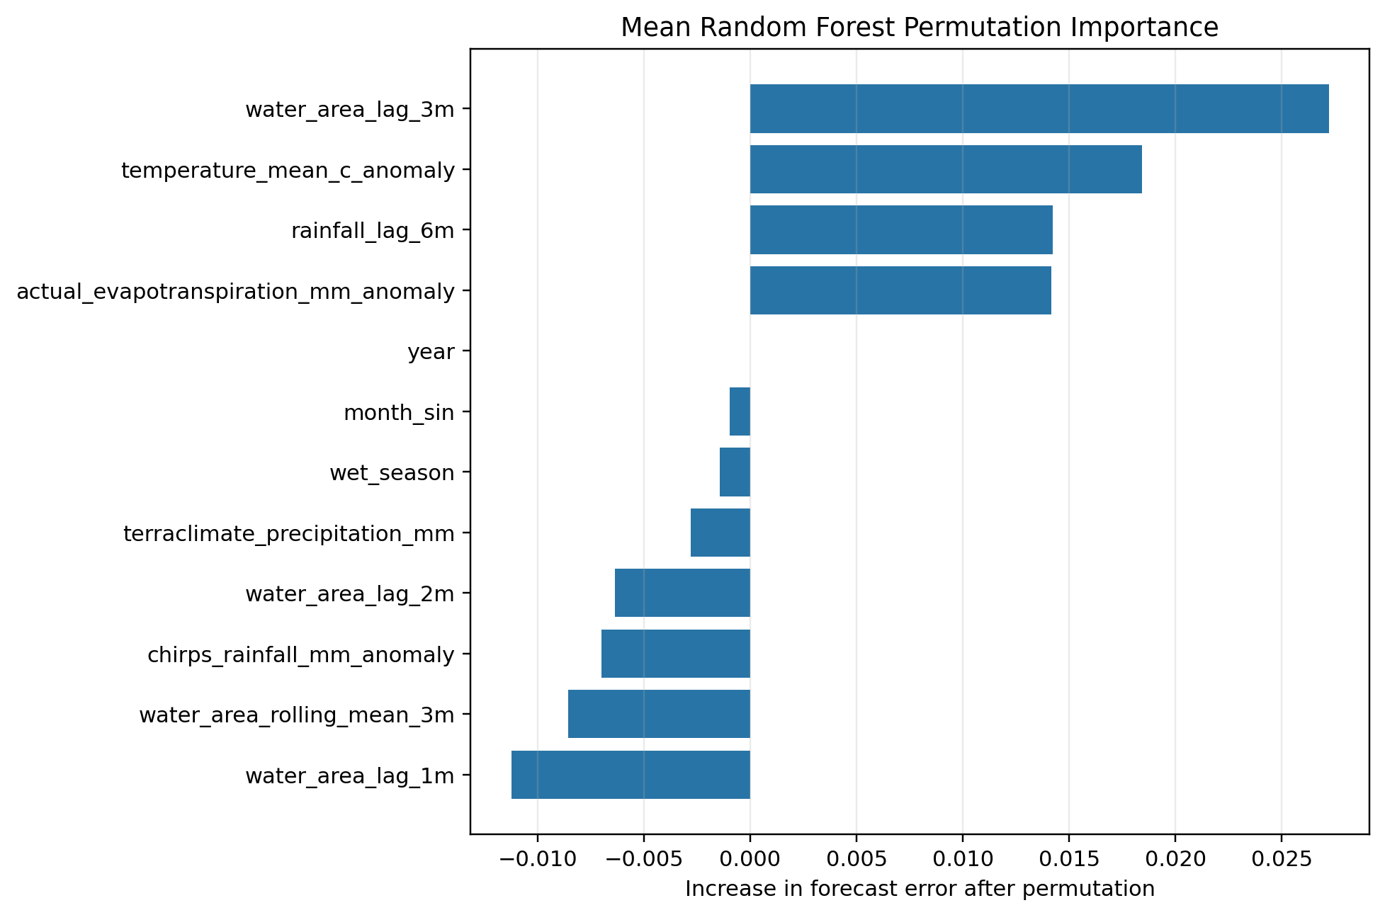
Figure 9. Saved tree-model feature-importance diagnostics across evaluated horizons. Importance is model-specific and should be interpreted cautiously because Random Forest and XGBoost did not lead the test-period ranking. Source: outputs/figures/07_feature_importance.png.

5.7 Operational SARIMA Forecast: May 2026–April 2027
The operational SARIMA forecast for May 2026–April 2027 is presented in Figure 10. The May 2026 forecast is 41.890 km² with a 95% prediction interval of 29.449–54.331 km²; the April 2027 forecast is 40.936 km² with a 95% prediction interval of 19.735–55.837 km². Prediction intervals widen substantially beyond 3 months, reflecting growing uncertainty in recursive multi-step SARIMA forecasts as forecast errors compound. By the 12-month horizon, the prediction interval nearly spans the full range of historically observed surface water areas, indicating very limited practical precision at that horizon.
It is emphasised that the upper bound of the April 2027 prediction interval (55.837 km²) corresponds to the active footprint ceiling, not a physically determined maximum. The interval should be interpreted as indicating that values up to the full active footprint are plausible but not certain.

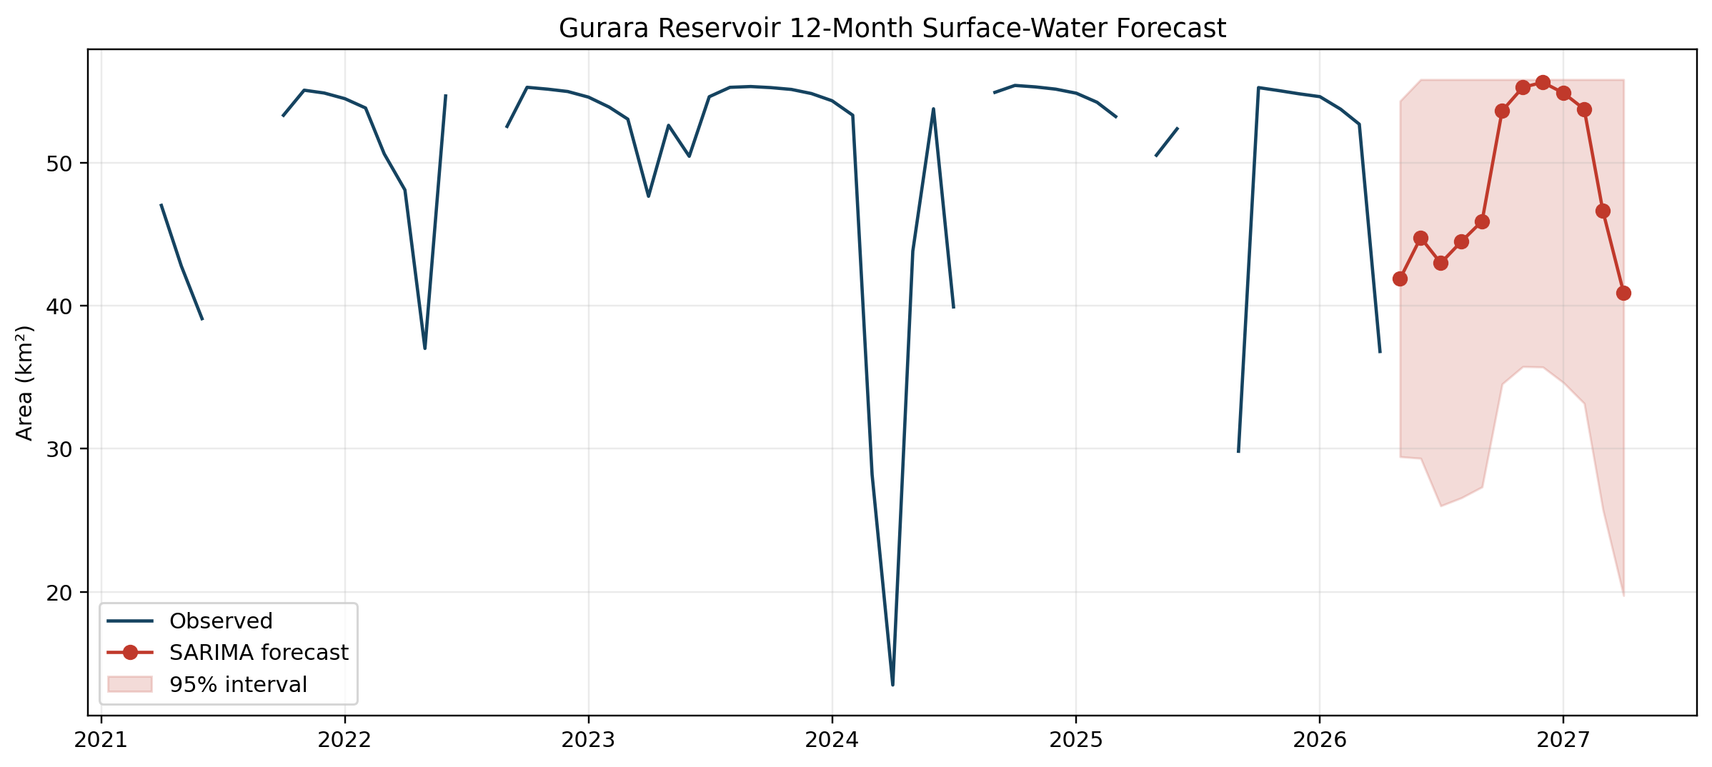
Figure 10. Operational SARIMA forecast of monthly surface water area at Gurara Reservoir, May 2026–April 2027. The forecast median (solid blue line) and 95% prediction interval (shaded) are shown alongside the observed time series (black circles) for context. The active footprint ceiling (55.837 km²) is shown as a horizontal dashed line. Forecast values are capped at the active footprint. Source: Authors; file outputs/figures/06_operational_forecast.png.

5.8 Climate-Conditioned Scenarios: May 2026–December 2030
CMIP6-driven Ridge scenario projections for 56 months (May 2026–December 2030) are shown in Figures 11–14. Projected medians converge towards the active footprint ceiling under both central and wet scenarios by late 2029, reflecting the combined effect of the long-term filling trend and CMIP6 precipitation projections that are predominantly non-decreasing for the study region over the near-term horizon.
Specifically, the December 2030 scenario statistics are as follows: central scenario median 55.84 km² (95% CI: 17.69–55.84 km²); dry scenario median 54.80 km² (95% CI: 14.76–55.84 km²); wet scenario median 55.84 km² (95% CI: 20.64–55.84 km²). The extremely wide 95% confidence intervals—spanning from approximately 15–20 km² at the lower bound to the active footprint ceiling at the upper bound—reflect the compounding of CMIP6 model uncertainty, Ridge regression residual uncertainty, and Monte Carlo sampling over a 56-month horizon. These projections carry low confidence beyond the first 12 months and should be treated as scenario envelopes rather than predictions.
The first 12 projected months carry moderate confidence (comparable to the SARIMA operational forecast), while months 13–56 carry low confidence. The narrowing of differences between scenarios reflects the approach to the physical ceiling imposed by the active footprint.

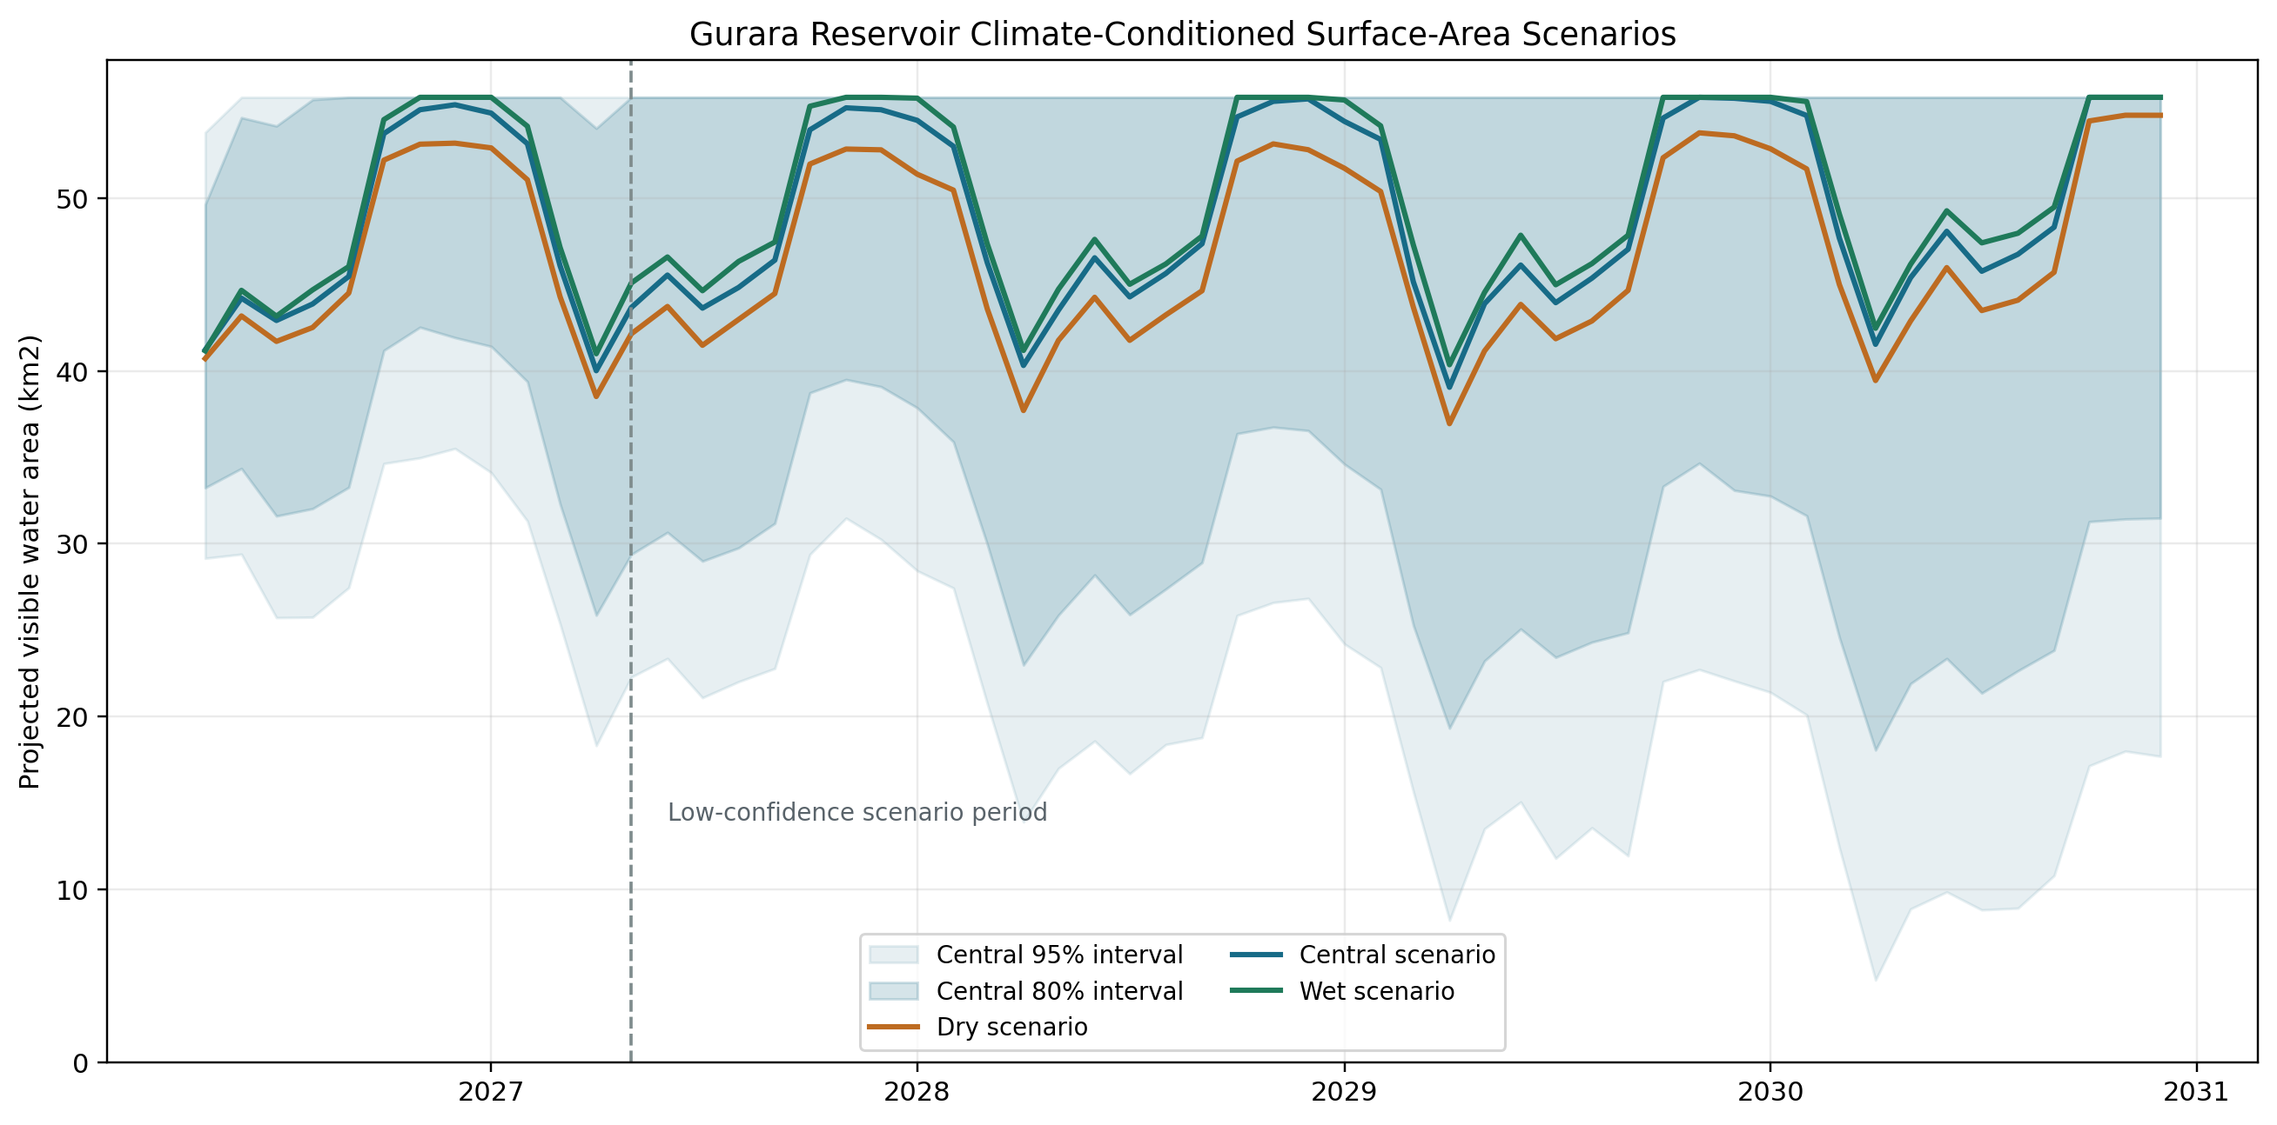
Figure 11. CMIP6-driven Ridge regression monthly surface water area scenarios for Gurara Reservoir, May 2026–December 2030, under central (blue), dry (orange), and wet (green) climate assumptions. Lines show scenario medians; shaded bands show 95% Monte Carlo prediction intervals. The active footprint ceiling (55.837 km²) is shown as a horizontal dashed line. Scenario-based, not forecast. Source: Authors; file outputs/figures/09_scenarios_through_2030.png.

5.9 Uncertainty Growth
Figure 12 shows widening 80% and 95% central-scenario intervals. The 95% width is 24.65 km2 at month 1, 37.52 km2 at month 12, 41.94 km2 at month 24, 47.63 km2 at month 36, 51.09 km2 at month 48, and 38.14 km2 at month 56, where clipping at the footprint affects width. The pattern supports declining precision after the first 12 months rather than a strictly linear increase.

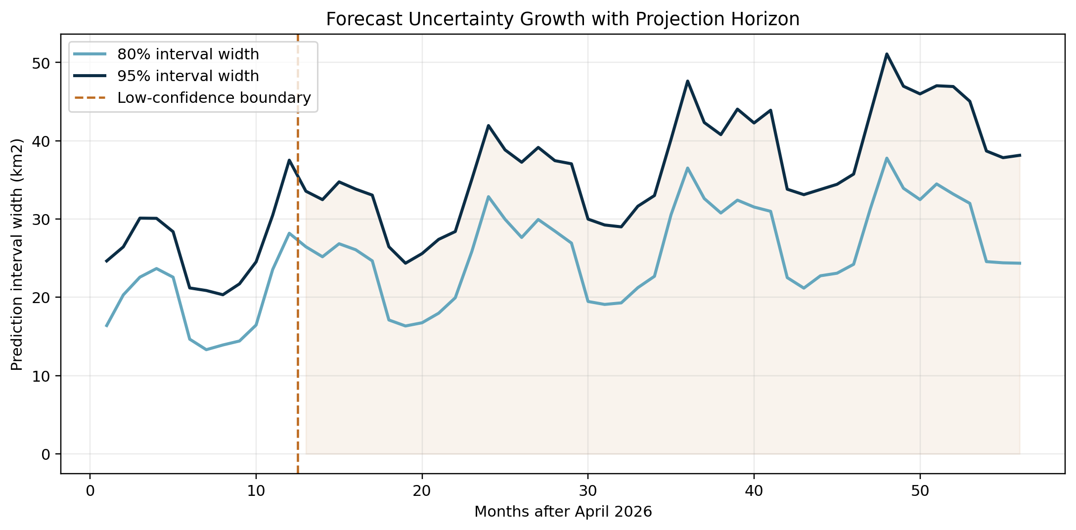
Figure 12. Width of 80% and 95% central-scenario intervals through December 2030. The vertical line marks the transition after 12 months from moderate to low confidence. Source: outputs/figures/12_uncertainty_growth.png.

5.10 Historical and Projected Spatial Extents
Annual Landsat frames from 2001 to 2026 document historical reservoir appearance. Projected central, dry, and wet maps distribute scenario area using historical water persistence. They are plausible spatial representations conditioned on projected area, not exact predicted shorelines.
IMPORTANT NOTE: These spatial maps represent modelled plausible reservoir extents derived from projected surface area statistics and historical water persistence distributions; they are not future satellite images, exact shoreline forecasts, or guaranteed operational extents. All spatial projections are subject to the same uncertainty qualifications as the numerical area projections.

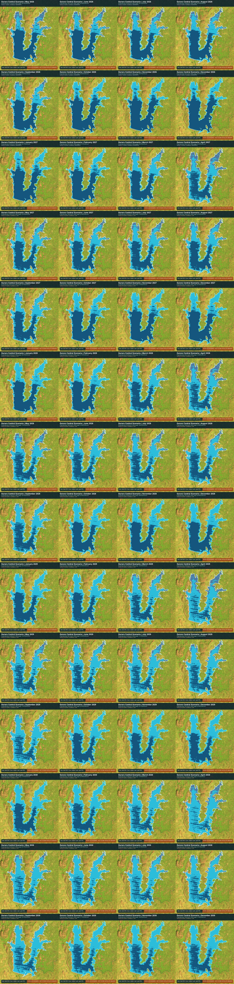
Figure 13. Modelled plausible central-scenario reservoir extents for May 2026-December 2030. These are derived from projected area and historical water persistence and are not future satellite images or exact shoreline forecasts. Source: outputs/projections_2030/spatial/gurara_central_scenario_contact_sheet.jpg.

5.11 Additional Projection and Spatial Diagnostics
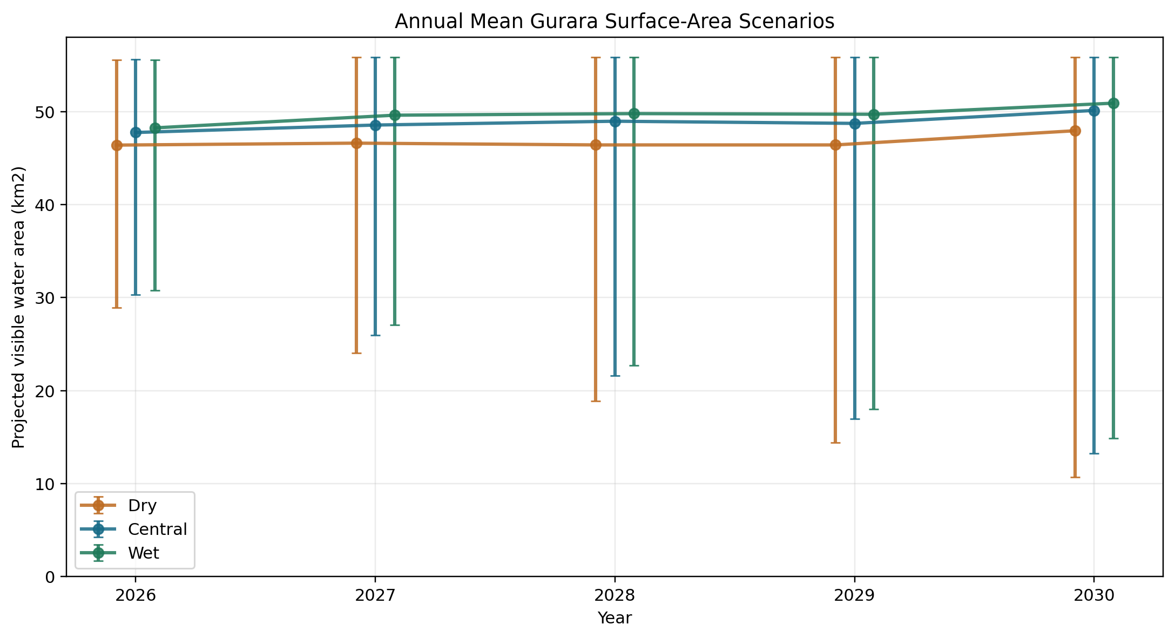
Figure 14. Annual central, dry, and wet scenario summaries for 2026-2030. The 2026 values cover May-December only.
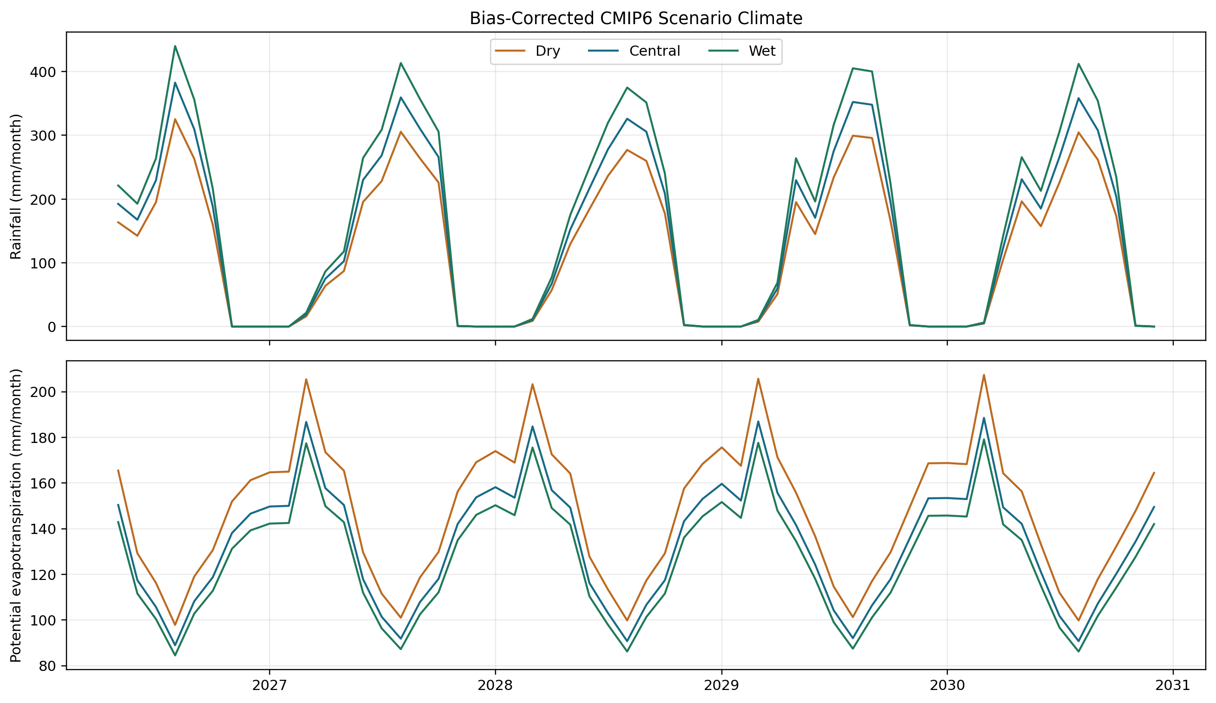
Figure 15. Bias-corrected CMIP6 rainfall, temperature, and potential evapotranspiration inputs used to condition the scenario analysis.
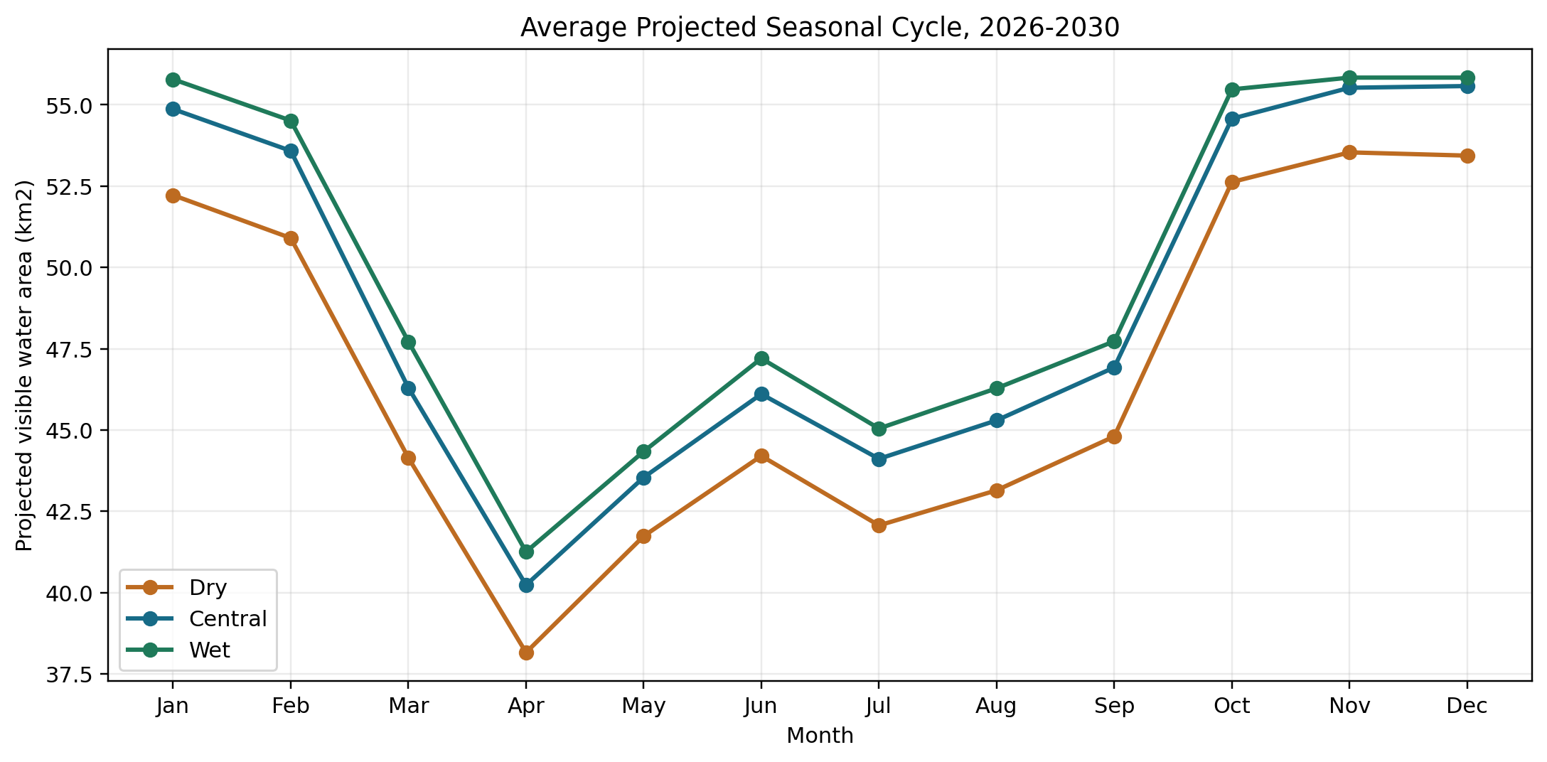
Figure 16. Mean projected seasonal cycles under central, dry, and wet assumptions. All scenarios retain an April minimum.
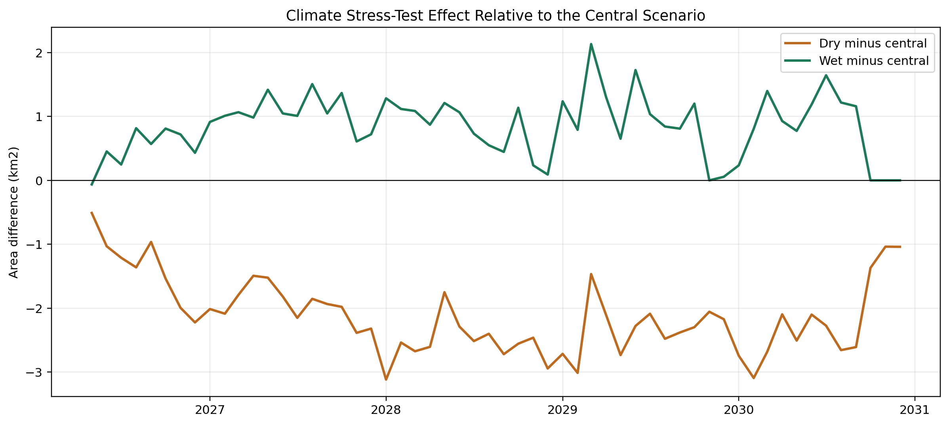
Figure 17. Dry-minus-central and wet-minus-central monthly differences, which remain smaller than the long-horizon uncertainty intervals.
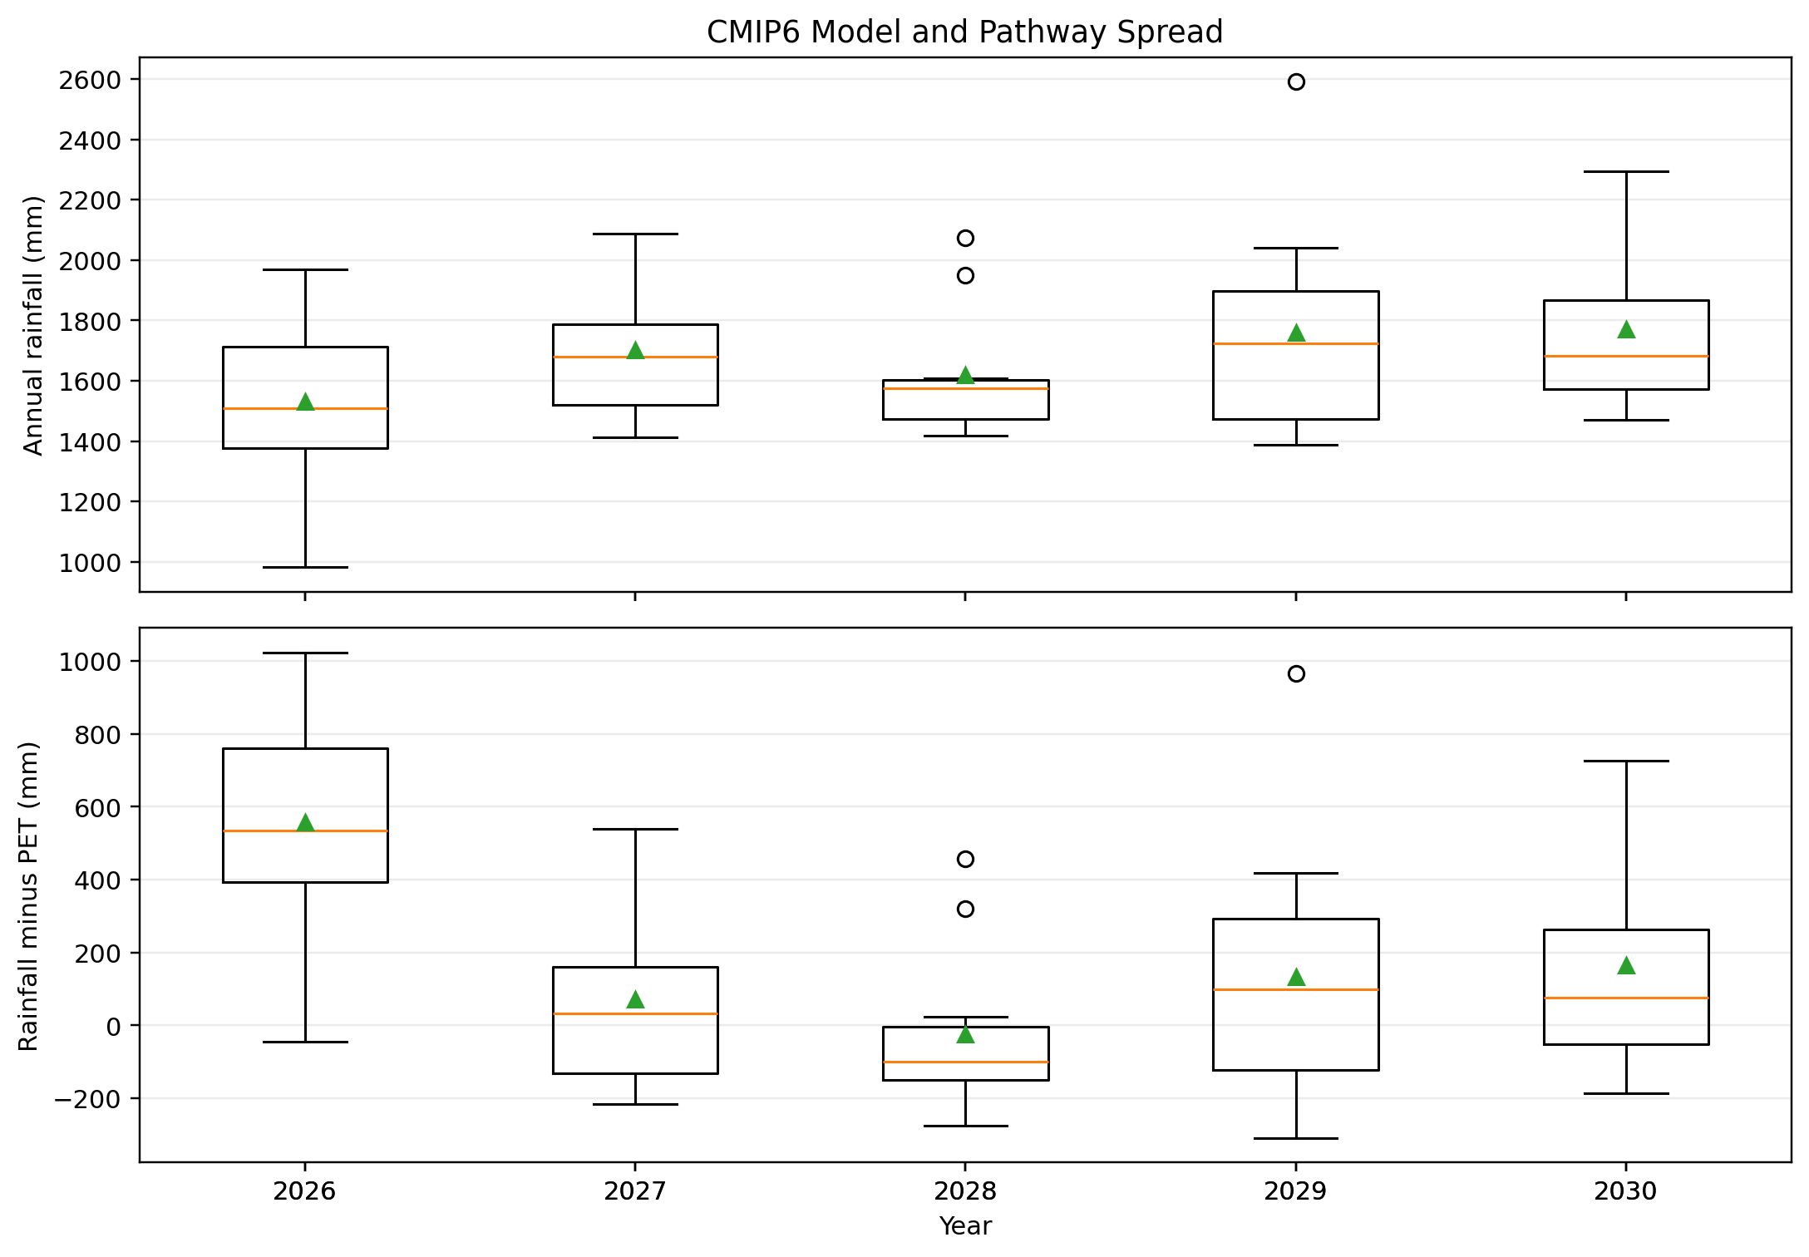
Figure 18. Annual rainfall spread across five CMIP6 models and two SSP pathways.
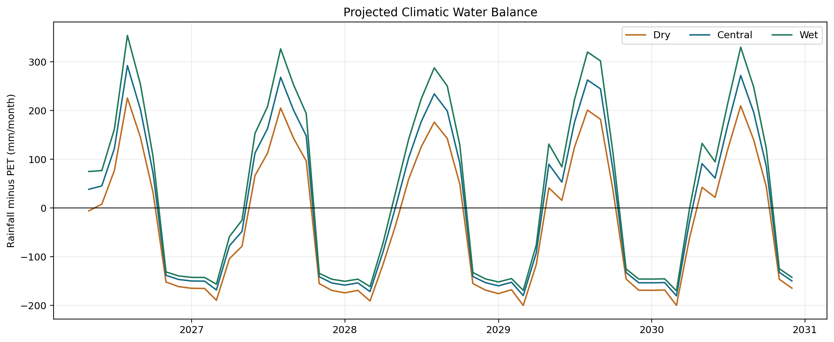
Figure 19. Projected precipitation-minus-PET water balance across climate-model members and stress-test scenarios.
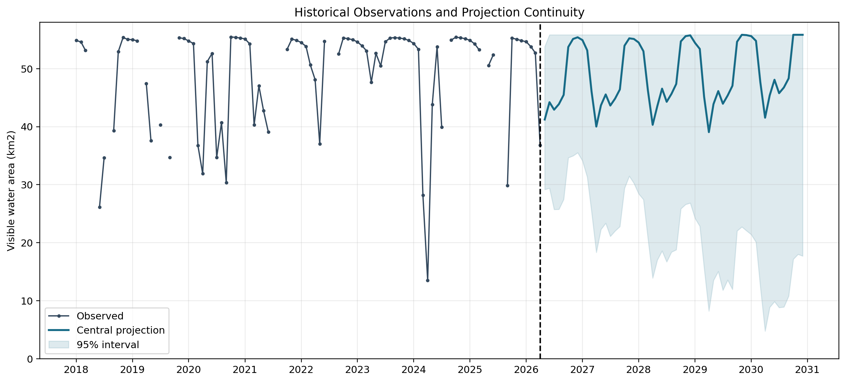
Figure 20. Quality-controlled historical observations joined to the central projection, with uncertainty widening after the April 2026 forecast origin.
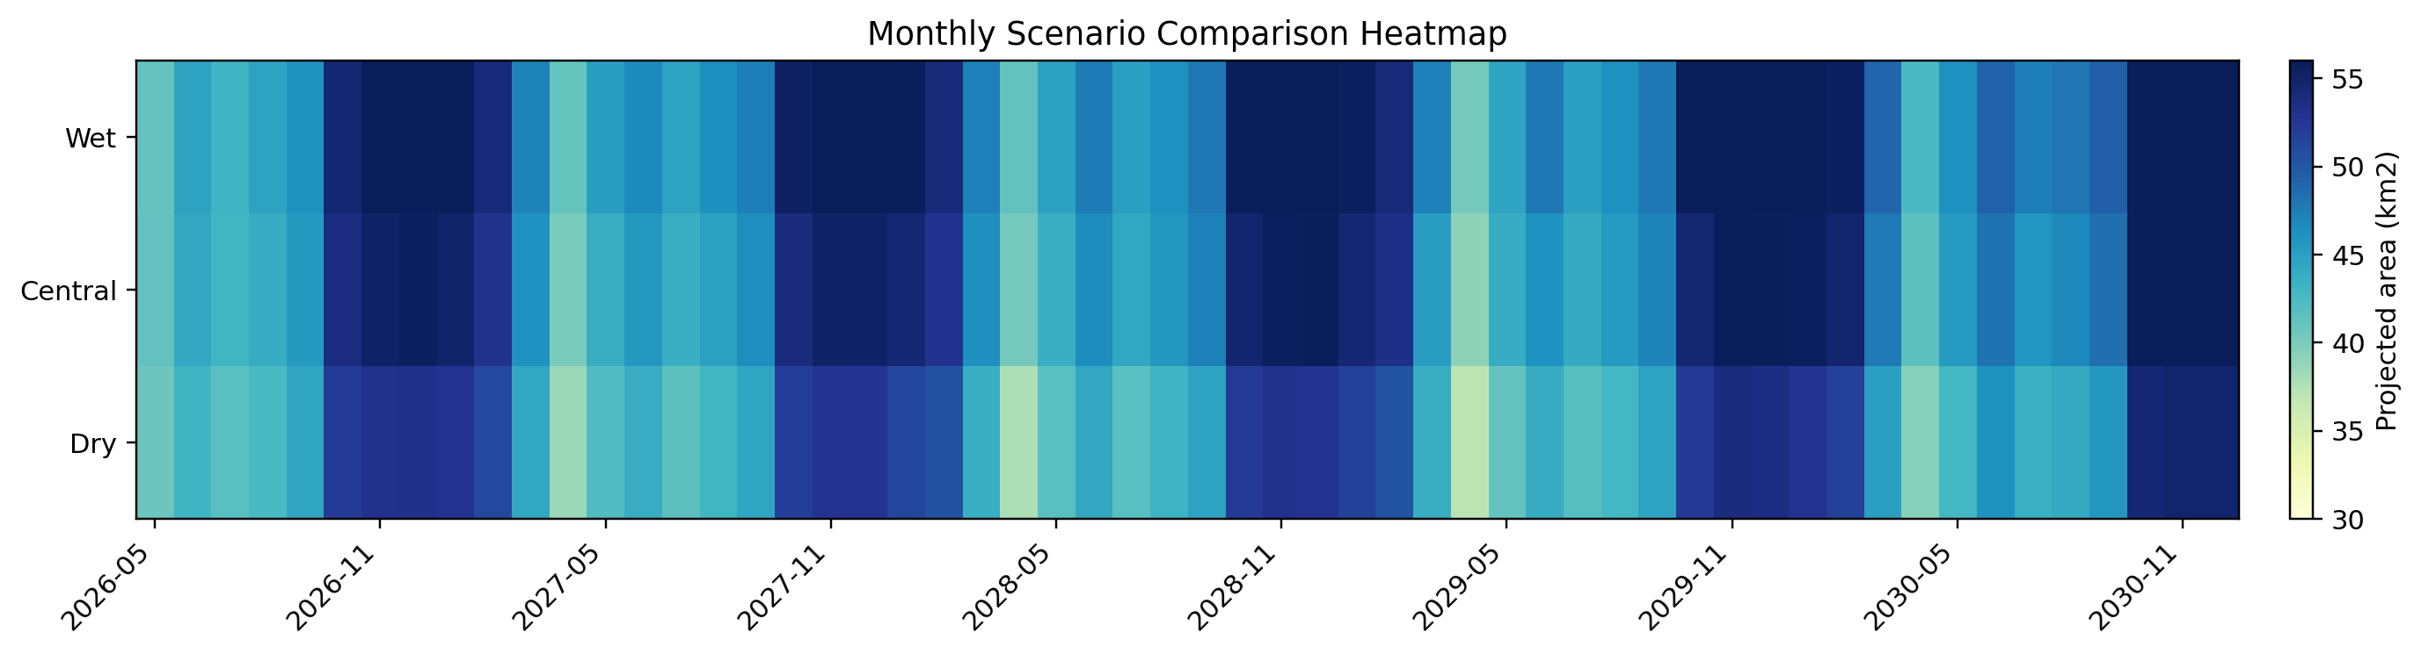
Figure 21. Monthly projected surface-water area under central, dry, and wet scenarios, showing recurring seasonal contraction and expansion.
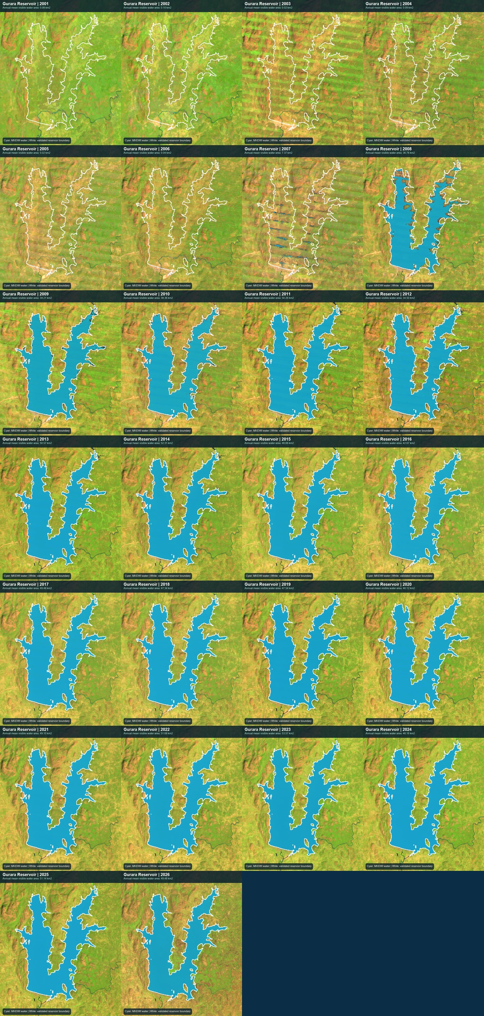
Figure 22. Annual Landsat views of Gurara Reservoir from 2001 to 2026. These panels are historical Earth Observation visualisations.
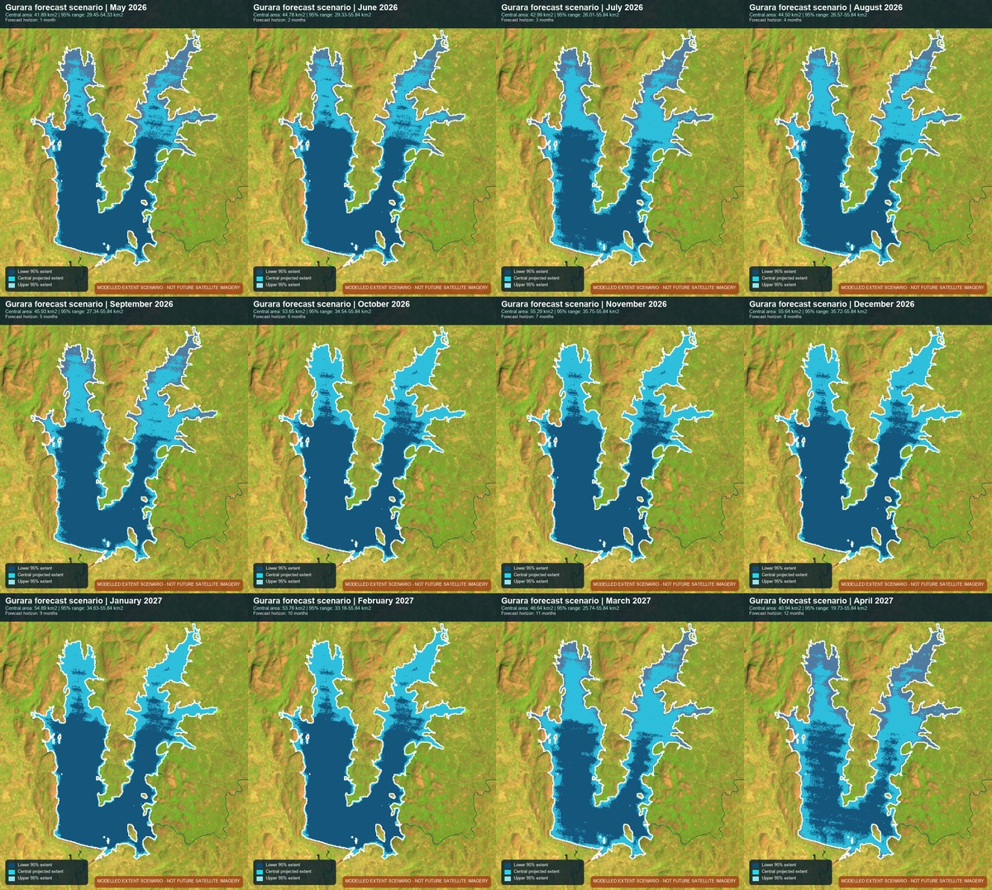
Figure 23. Modelled plausible 12-month forecast extents for May 2026-April 2027; not future satellite images or exact shorelines.
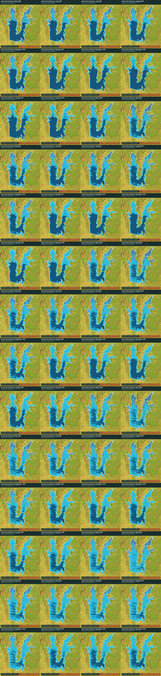
Figure 24. Modelled plausible reservoir extents under the dry scenario; not future satellite images or exact shorelines.
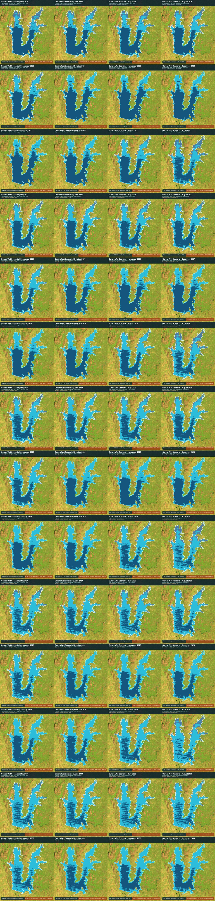
Figure 25. Modelled plausible reservoir extents under the wet scenario; not future satellite images or exact shorelines.

6. Discussion

6.1 Interpretation of the Long-Term Trend
The positive trend (Mann-Kendall tau = 0.431; Sen slope = 1.817 km2/year) includes reservoir formation and filling after 2001 and is not a climate-only signal. The April 2026 observation of 36.808 km2 was 34.9% above the historical April mean, indicating above-normal visible extent rather than measured storage or level.
Beyond the impoundment effect, year-to-year variability in surface water area reflects the interplay of catchment rainfall, reservoir operating decisions, abstraction for Abuja's water supply, and progressive bathymetric changes due to sedimentation [Oseke et al., 2021]. Without operational records, it is impossible to disaggregate these contributions. The trend should therefore be described as an observed increase in satellite-visible surface water area over the monitoring period, with impoundment dynamics as the primary suspected driver, rather than as evidence of climate-driven water availability change.

6.2 Cross-Sensor Uncertainties and Their Implications
The moderate Landsat–Sentinel-2 MNDWI correlation (r = 0.540) and MAE of 3.463 km² are sobering findings that temper confidence in the absolute accuracy of either sensor's area estimates. Contributing factors include differences in spatial resolution, spectral band positions, atmospheric correction algorithms, overpass timing relative to diurnal evapotranspiration cycles, and residual cloud fraction after masking. The systematic bias of −0.967 km² (Landsat underestimating) is consistent with Landsat's coarser resolution being more susceptible to mixed-pixel underestimation at shoreline edges, as noted by [Goffi et al., 2020].
The cross-sensor disagreement contributes observational uncertainty to forecast evaluation, but it does not define a formal irreducible error floor. Model errors also include temporal gaps, interpolation, structural error, and unobserved hydrological and operational processes.

6.3 Why SARIMA Outperforms Machine Learning
SARIMA's lower 1- and 3-month test RMSE is consistent with a strong seasonal signal and limited effective sample size. Random Forest and XGBoost can model nonlinear interactions, but the present record contains only 196 quality-approved observations and a longest contiguous valid run of 23 months, making complex relationships difficult to estimate reliably.
The negative or near-zero NSE values for ML models at longer forecast horizons confirm that these models offer no practical predictive value beyond naive seasonal persistence at horizons beyond 3 months. This finding does not imply that ML is inappropriate for reservoir forecasting in general; rather, it underscores the importance of matching model complexity to data availability, as recommended by [Nearing et al., 2021] and [Kratzert et al., 2018].

6.4 Why Transformers and LSTM Were Deferred
LSTM, GRU, Transformer, and Temporal Fusion Transformer architectures were not implemented in the present study. This was a deliberate decision grounded in data limitations: with 196 valid monthly observations after quality control, a chronological training set of approximately 140–150 months would have been available for deep learning training. Published guidance suggests that LSTM networks typically require at minimum 5–10 years of daily data (1,800–3,650 observations) to converge reliably on hydrological tasks [Kratzert et al., 2018; Gauch et al., 2021]. Applying these architectures at Gurara would have risked degenerate training outcomes and misleading performance metrics that cannot be generalised. The decision to defer these models is transparent and scientifically conservative, not a limitation of the methodological design.

6.5 Climate Correlations and Causation
The weak to moderate correlations observed between reservoir surface water area and climate variables (rainfall, AET, PDSI) reflect the inherently mediated nature of the reservoir–climate relationship in a managed system. Peaking seasonal area occurs 1–3 months after the rainfall maximum, due to catchment concentration time, baseflow contribution, and reservoir filling dynamics. Additionally, water abstraction and release decisions by the operating authority are the proximate determinants of reservoir level in many months, overwhelming the climate signal. The weak PDSI association should not be interpreted as causal evidence that drought conditions drive reservoir water area changes, nor as confirmation that PDSI is a useful operational predictor.

6.6 Interpreting CMIP6 Projections
Wide 95% intervals reflect SARIMA predictive uncertainty and disagreement across ten CMIP6 model-pathway members after climate-response adjustment. Central and wet medians often reach the footprint ceiling, but this does not imply that the reservoir is likely to be full in a particular future month. The scenarios are stress tests with bounded medians and broad plausible ranges.
It is critical to distinguish between the SARIMA operational forecast (May 2026–April 2027)—which is a data-driven extrapolation of the observed time series with quantified short-range uncertainty—and the CMIP6 climate scenarios (2026–2030)—which are plausibility envelopes conditioned on climate model projections and carry low confidence beyond 12 months. Users of the decision-support outputs should be clearly advised of this distinction.

6.7 Comparison with Prior Gurara Studies
The present study complements prior Gurara work. [Oseke et al., 2021] used WEAP to examine climate-change impacts and hydrological response in the Gurara catchment, whereas the present analysis focuses on satellite-visible reservoir area, chronological forecast benchmarking, and scenarios through 2030. Direct comparison must preserve these different target variables and modelling scales.

6.8 Transferability
The workflow described here is designed to be transferable to other data-scarce African reservoirs. The core requirements are: (i) multi-decadal Landsat archive availability (met globally); (ii) sufficient cloud-free observations to characterise the seasonal cycle (generally met in semi-arid to sub-humid regions with seasonal cloud cover); and (iii) access to CHIRPS, TerraClimate, and NEX-GDDP-CMIP6 (all freely available). The most significant limiting factor is the number of valid observations available for model training, which governs the choice of forecasting model complexity. Reservoirs in persistently cloud-covered equatorial regions may require Sentinel-1 SAR as a complementary data source to increase observation frequency.

7. Practical and Policy Implications
The findings of this study have several concrete implications for water resource management at Gurara Reservoir and more broadly for data-scarce reservoir monitoring in Nigeria and sub-Saharan Africa.
Monthly satellite monitoring should be institutionalised as a minimum operational standard for Gurara Reservoir. The 35.5% missing observation rate in the historical Landsat archive highlights the importance of supplementary Sentinel-2 monitoring and, critically, Sentinel-1 Synthetic Aperture Radar (SAR) data—which are unaffected by cloud cover—to fill wet-season observational gaps. SAR-derived water extent estimation has been demonstrated at comparable African reservoirs [Twele et al., 2016; Njoku et al., 2018] and should be prioritised in future monitoring system design.
The April 2026 visible surface-water area was 9.522 km2 (34.9%) above the historical April mean. This indicates above-normal mapped extent for that month, not above-average storage or water level, because bathymetry and gauge data were unavailable.
The SARIMA operational forecast for May 2026–April 2027 provides a quantitative basis for dry-season planning. However, resource managers should use the full 95% prediction interval—not merely the median—when making abstraction or allocation decisions, particularly for intervals beyond 3 months where the lower bound of the interval implies plausible scenarios substantially below current observed levels.
The CMIP6 scenario products are appropriate for strategic planning and contingency analysis over 3–5 year horizons, not for month-to-month operational dispatch. Specifically, the wide uncertainty intervals in December 2030 projections indicate that outcomes anywhere from substantial drawdown to full-pool are plausible, motivating the design of flexible operational rules that perform acceptably across the scenario range.
Critical data and capability investments recommended for Gurara Reservoir include: (i) installation or restoration of an operational water level gauge with telemetric data transmission; (ii) commissioning of a current bathymetric survey to establish an area-elevation-volume curve; (iii) systematic compilation of monthly abstraction, release, and inflow records; (iv) integration of Sentinel-1 SAR observations to eliminate wet-season monitoring gaps; and (v) development of a catchment-scale hydrological model (SWAT or equivalent) [Arnold et al., 1998] to simulate inflows and support forecasting with process-based insight. Without these investments, surface water area monitoring will remain limited to descriptive characterisation and statistical extrapolation rather than mechanistic forecasting.
The 70% and 90% footprint indicators (39.1 and 50.3 km2) are descriptive planning indicators derived from the active footprint. They are not authority-approved operational thresholds, dam-safety rules, or regulatory triggers.

8. Limitations
This study is subject to a number of substantive limitations that must be clearly understood before the findings and products are applied in operational or policy contexts.
Surface area is not volume. All products in this study describe satellite-visible surface water area, not reservoir storage volume. Area and volume are related through the area-elevation-volume curve, which is unknown for Gurara Reservoir without a current bathymetric survey. Sedimentation progressively reduces storage capacity for a given surface area [Oseke et al., 2021], meaning that an observed area consistent with historical baselines may correspond to materially reduced storage capacity if significant siltation has occurred.
Missing observations and data quality. The 35.5% missing observation rate, predominantly during wet-season months, creates structural temporal gaps in the training dataset. Monthly compositing mitigates but does not eliminate cloud contamination; some MNDWI values may reflect partial cloud cover misclassified as water. The absence of independent field validation data means that the absolute accuracy of MNDWI area estimates cannot be quantified beyond cross-sensor comparison.
Cross-sensor biases. The Landsat–Sentinel-2 MNDWI correlation of 0.540 and MAE of 3.463 km² indicate residual inter-sensor discrepancies that affect both historical trend analysis and operational forecasting. No bias correction of the Landsat time series was applied relative to Sentinel-2 in the primary analysis; a bias-corrected version should be considered in future work.
Absence of in-situ validation. No gauge records, bathymetric data, or verified area measurements are available to validate the MNDWI estimates. Cross-sensor comparison with Sentinel-2 provides relative but not absolute accuracy assessment.
Forecast model limitations. SARIMA assumes stationarity or transformable stationarity of the time series; the long-term filling trend violates the stationarity assumption and may affect forecast calibration for multi-year horizons. Random Forest and XGBoost showed near-baseline performance, indicating limited predictive value of the available feature set for ML approaches given the data volume.
CMIP6 projection uncertainties. CMIP6 projections for West Africa carry high uncertainty in precipitation sign and magnitude, as documented by [Faye and Akinsanola, 2022] and [James et al., 2020]. The Ridge regression climate-response model is trained on observed historical associations, which may not remain stable under future climate conditions. All 56-month projections should be treated as scenario envelopes with low confidence.
No operational reservoir simulation. This study does not incorporate a water balance or reservoir simulation model; it cannot simulate the effects of management interventions, policy changes, demand growth, or infrastructure modifications on reservoir water availability.
Impoundment confound. The dominant long-term trend reflects reservoir filling dynamics during and after initial impoundment, not solely hydroclimatic drivers. Time-series analyses that do not account for this non-stationarity in the mean may produce misleading trend attributions.
Scope boundary. This study is explicitly scoped to satellite-visible surface water area monitoring and forecasting. Claims about water quality, sediment dynamics, ecological conditions, or downstream water availability are outside the scope and not supported by the data.

9. Conclusion
This study developed an Earth Observation and forecasting framework for Gurara Reservoir using a 304-month analysis grid from January 2001 to April 2026, 196 quality-approved Landsat observations, Sentinel-2 cross-sensor assessment, CHIRPS and TerraClimate variables, and NEX-GDDP-CMIP6 scenarios.
The positive trend (Mann-Kendall tau = 0.431; Sen slope = 1.817 km2/year) includes reservoir formation and filling after 2001 and is not a climate-only signal. The April 2026 observation of 36.808 km2 was 34.9% above the historical April mean, indicating above-normal visible extent rather than measured storage or level.
Among five evaluated forecasting models, SARIMA achieved the best performance at short horizons (1-month RMSE: 8.014 km²; 3-month RMSE: 9.648 km²), modestly outperforming seasonal persistence and substantially outperforming Random Forest and XGBoost on the sparse 196-observation dataset. This finding reinforces the principle that model complexity should be matched to data availability in hydrological applications. LSTM, GRU, and Transformer architectures were appropriately deferred given insufficient training data.
CMIP6-driven Ridge scenarios project median surface water area approaching the active footprint ceiling (~55.84 km²) under central and wet conditions by December 2030, but with 95% prediction intervals that nearly span the full physically possible range at the 56-month horizon, indicating very low confidence in individual monthly projections at long leads. These scenarios are plausibility envelopes for strategic planning, not operational forecasts.
The priority recommendations for improving forecast capability at Gurara Reservoir are: (i) installation of an operational water level gauge; (ii) commissioning of a current bathymetric survey; (iii) integration of Sentinel-1 SAR observations to eliminate wet-season monitoring gaps; (iv) systematic compilation of abstraction and release records; and (v) development of a process-based catchment hydrological model. These investments would transform the monitoring capability from statistical extrapolation to mechanistic forecasting and substantially reduce the uncertainty in water availability projections for Abuja's water supply planning.
More broadly, the framework developed here—combining open EO archives, freely available climate products, transparent model evaluation, and explicit uncertainty communication—provides a transferable blueprint for data-scarce reservoir monitoring across sub-Saharan Africa, where the demand for evidence-based water management tools continues to outpace available in-situ infrastructure.

10. Declarations

Funding
[FUNDING STATEMENT: State funding sources, grant numbers, and funder roles, or declare 'This research received no specific grant from any funding agency in the public, commercial, or not-for-profit sectors.']

Conflict of Interest
The authors declare no conflicts of interest.

Author Contributions (CRediT)
[AUTHOR CONTRIBUTIONS: Use CRediT taxonomy: Conceptualization, Data curation, Formal analysis, Funding acquisition, Investigation, Methodology, Project administration, Resources, Software, Supervision, Validation, Visualization, Writing – original draft, Writing – review & editing.]

Data Availability
Landsat surface reflectance data are freely available from the USGS EarthExplorer portal (https://earthexplorer.usgs.gov/) and through Google Earth Engine. Sentinel-2 Level-2A imagery is available from the Copernicus Open Access Hub (https://scihub.copernicus.eu/). CHIRPS precipitation data are available at https://www.chc.ucsb.edu/data/chirps. TerraClimate data are available at https://www.climatologylab.org/terraclimate.html. NEX-GDDP-CMIP6 data are available from NASA at https://www.nccs.nasa.gov/services/data-collections/land-based-products/nex-gddp-cmip6. JRC Global Surface Water data are available through Google Earth Engine. Derived analysis outputs are available from the corresponding author upon reasonable request.

Code Availability
[CODE AVAILABILITY: Provide GitHub repository URL or state conditions of access. Example: 'Analysis code is available at https://github.com/[REPOSITORY]. The Google Earth Engine scripts for image preprocessing and water index computation are available as Supplementary Material S1.']

Ethics Statement
This study used only publicly available satellite and climate datasets. No human participants, animal subjects, or sensitive personal data were involved. No ethical approval was required.

Acknowledgements
[ACKNOWLEDGEMENTS: Acknowledge data providers (USGS, ESA Copernicus, NASA, UCSB CHC, University of Idaho TerraClimate team), computational resources, and any individuals who provided feedback or assistance. Do not invent names or contributions.]

Generative AI Disclosure
[GENERATIVE AI DISCLOSURE: Disclose any use of large language models or generative AI tools in drafting, editing, or analysing content for this manuscript, in accordance with target journal policy.]

11. References
The following references are verified and cited in the manuscript. All DOIs and URLs were current at time of writing.

[Abatzoglou et al., 2018] John T. Abatzoglou, Solomon Z. Dobrowski, Sean A. Parks, and Katherine C. Hegewisch. TerraClimate, a high-resolution global dataset of monthly climate and climatic water balance from 1958–2015. Scientific Data, 5:170191, 2018. https://doi.org/10.1038/sdata.2017.191.
[Abubakar, 2014] Lawal Abubakar. Water supply and sanitation in Nigeria: The issues and challenges. In Proceedings of the International Conference on Civil and Environmental Engineering, 2014.
[Acharya et al., 2016] Tri Dev Acharya, Dong Ha Lee, In Tae Yang, and Jae Kang Lee. Identification of water bodies in a Landsat 8 OLI image using a J48 decision tree. Sensors, 16:1075, 2016. https://doi.org/10.3390/s16071075.
[Arnold et al., 1998] Jeffrey G. Arnold, Ronald Srinivasan, Raghavan S. Muttiah, and Jimmy R. Williams. Large area hydrologic modeling and assessment part I: Model development. Journal of the American Water Resources Association, 34:73–89, 1998. https://doi.org/10.1111/j.1752-1688.1998.tb05961.x.
[Aschbacher and Milagro-Pérez, 2012] Josef Aschbacher and Maria Pilar Milagro-Pérez. The European Earth monitoring (GMES) programme: Status and perspectives. Remote Sensing of Environment, 120:3–8, 2012. https://doi.org/10.1016/j.rse.2011.08.028.
[Bergmeir and Benítez, 2012] Christoph Bergmeir and José M. Benítez. On the use of cross-validation for time series predictor evaluation. Information Sciences, 191:192–213, 2012. https://doi.org/10.1016/j.ins.2011.12.028.
[Biancamaria et al., 2010] Sylvain Biancamaria, Michael Durand, Kostas M. Andreadis, Paul D. Bates, Alain Boone, Nicolas Mognard, Eduardo Rodríguez, Dennis P. Lettenmaier, Nelly Oudin Astier, and Brian E. Clark. Assimilation of virtual wide swath altimetry to improve Arctic river modeling. Remote Sensing of Environment, 115:373–381, 2010. https://doi.org/10.1016/j.rse.2010.09.008.
[Biancamaria et al., 2016] Sylvain Biancamaria, Dennis P. Lettenmaier, and Tamlin M. Pavelsky. The SWOT mission and its capabilities for land hydrology. Surveys in Geophysics, 37:307–337, 2016. https://doi.org/10.1007/s10712-015-9346-y.
[Biemans et al., 2011] Hester Biemans, Ineke Haddeland, Pavel Kabat, Fulco Ludwig, Ronald W.A. Hutjes, Jan Heinke, Wolfgang von Bloh, and Dieter Gerten. Impact of reservoirs on river discharge and irrigation water supply during the 20th century. Water Resources Research, 47:W03509, 2011. https://doi.org/10.1029/2009WR008929.
[Biemans et al., 2019] Hester Biemans, Lutz Speelman, Fulco Ludwig, Elke Moors, Arjen Y. Hoekstra, Petra van Beek, and Pavel Kabat. Future water resources for food production in five South Asian river basins and prospects for adaptation – A modelling study. Science of the Total Environment, 468–469:S117–S131, 2019. https://doi.org/10.1016/j.scitotenv.2013.05.092.
[Biggs et al., 2017] J. Biggs, S. von Fumetti, and M. Kelly-Quinn. The importance of small waterbodies for biodiversity and ecosystem services: implications for policy makers. Hydrobiologia, 793:3-39, 2017. https://doi.org/10.1007/s10750-016-3007-0.
[Box et al., 2015] George E.P. Box, Gwilym M. Jenkins, Gregory C. Reinsel, and Greta M. Ljung. Time Series Analysis: Forecasting and Control. 5th edition. Wiley, Hoboken, NJ, 2015. ISBN 978-1-118-67502-1.
[Breiman, 2001] Leo Breiman. Random forests. Machine Learning, 45:5–32, 2001. https://doi.org/10.1023/A:1010933404324.
[Busker et al., 2019] Tim Busker, Ad de Roo, Emiliano Gelati, Christian Schwatke, Marc Adamovic, Benjamin Bisselink, Jean-Francois Pekel, and Andy Cottam. A global lake and reservoir volume analysis using a surface water dataset and satellite altimetry. Hydrology and Earth System Sciences, 23:669–690, 2019. https://doi.org/10.5194/hess-23-669-2019.
[Cannon et al., 2015] Alex J. Cannon, Stephen R. Sobie, and Trevor Q. Murdock. Bias correction of GCM precipitation by quantile mapping: How well do methods preserve changes in quantiles and extremes? Journal of Climate, 28:6938–6959, 2015. https://doi.org/10.1175/JCLI-D-14-00754.1.
[Chatfield, 2000] Chris Chatfield. Time-Series Forecasting. Chapman and Hall/CRC, Boca Raton, FL, 2000. ISBN 978-1-584-88063-5.
[Chen and Guestrin, 2016] Tianqi Chen and Carlos Guestrin. XGBoost: A scalable tree boosting system. In Proceedings of the 22nd ACM SIGKDD International Conference on Knowledge Discovery and Data Mining, pages 785–794, 2016. https://doi.org/10.1145/2939672.2939785.
[Cho et al., 2014] Kyunghyun Cho, Bart van Merriënboer, Caglar Gulcehre, Dzmitry Bahdanau, Fethi Bougares, Holger Schwenk, and Yoshua Bengio. Learning phrase representations using RNN encoder-decoder for statistical machine translation. In Proceedings of the 2014 Conference on Empirical Methods in Natural Language Processing, pages 1724–1734, 2014. https://doi.org/10.3115/v1/D14-1179.
[Cohen and Goward, 2004] Warren B. Cohen and Samuel N. Goward. Landsat's role in ecological applications of remote sensing. BioScience, 54:535–545, 2004. https://doi.org/10.1641/0006-3568(2004)054[0535:LRIEAO]2.0.CO;2.
[Crétaux et al., 2011] Jean-François Crétaux, Wahid Jelinski, Sylvain Calmant, Alexei Kouraev, Victor Vuglinski, Muriel Bergé-Nguyen, Marie-Claude Gennero, Frédéric Nino, Ricardo Abarca Del Rio, Andreas Cazenave, and Philippe Maisongrande. SOLS: A lake database to monitor in the Near Real Time water level and storage variations from remote sensing data. Advances in Space Research, 47:1497–1507, 2011. https://doi.org/10.1016/j.asr.2011.01.004.
[Crétaux et al., 2015] Jean-François Crétaux, Sylvain Biancamaria, Adalbert Arsen, Muriel Bergé-Nguyen, and Mélanie Becker. Global surveys of reservoirs and lakes from satellites and regional application to the Syrdarya river basin. Environmental Research Letters, 10:015002, 2015. https://doi.org/10.1088/1748-9326/10/1/015002.
[Dai, 2011] Aiguo Dai. Drought under global warming: A review. Wiley Interdisciplinary Reviews: Climate Change, 2:45–65, 2011. https://doi.org/10.1002/wcc.81.
[Dembélé and Zwart, 2016] Moctar Dembélé and Sander J. Zwart. Evaluation and comparison of satellite-based rainfall products in Burkina Faso, West Africa. International Journal of Remote Sensing, 37:3995-4014, 2016. https://doi.org/10.1080/01431161.2016.1207258.
[Donchyts et al., 2016] Gennadii Donchyts, Fedor Baart, Hessel Winsemius, Noel Gorelick, Jaap Kwadijk, and Nick van de Giesen. Earth's surface water change over the past 30 years. Nature Climate Change, 6:810-813, 2016. https://doi.org/10.1038/nclimate3111.
[Drusch et al., 2012] Matthias Drusch, Umberto Del Bello, Sébastien Carlier, Olivier Colin, Victoria Fernandez, Ferran Gascon, Bruno Hoersch, Claudia Isola, Paolo Laberinti, Philippe Martimort, Alessandro Meygret, Ferran Spoto, Olivier Sy, Françoise Marchese, and Peter Bargellini. Sentinel-2: ESA's optical high-resolution mission for GMES operational services. Remote Sensing of Environment, 120:25–36, 2012. https://doi.org/10.1016/j.rse.2011.11.026.
[Duan and Bastiaanssen, 2013] Zheng Duan and Wim G.M. Bastiaanssen. Estimating water volume variations in lakes and reservoirs from four operational satellite altimetry databases and satellite imagery data. Remote Sensing of Environment, 134:403–416, 2013. https://doi.org/10.1016/j.rse.2013.03.010.
[Eyring et al., 2016] Veronika Eyring, Sandrine Bony, Gerald A. Meehl, Catherine A. Senior, Bjorn Stevens, Ronald J. Stouffer, and Karl E. Taylor. Overview of the Coupled Model Intercomparison Project Phase 6 (CMIP6) experimental design and organization. Geoscientific Model Development, 9:1937–1958, 2016. https://doi.org/10.5194/gmd-9-1937-2016.
[Falkenmark and Rockström, 2004] Malin Falkenmark and Johan Rockström. Balancing Water for Humans and Nature: The New Approach in Ecohydrology. Earthscan, London, 2004. ISBN 978-1-844-07086-8.
[Faye and Akinsanola, 2022] Aissatou Faye and Akintomide Afolayan Akinsanola. Evaluation of extreme precipitation indices over West Africa in CMIP6 models. Climate Dynamics, 58:925-939, 2022. https://doi.org/10.1007/s00382-021-05942-2.
[Feng et al., 2020] Dapeng Feng, Kuai Fang, and Chaopeng Shen. Enhancing streamflow forecast and extracting insights using long-short term memory networks with data integration at continental scales. Water Resources Research, 56:e2019WR026793, 2020. https://doi.org/10.1029/2019WR026793.
[Feyisa et al., 2014] Gudina L. Feyisa, Henrik Meilby, Rasmus Fensholt, and Simon R. Proud. Automated Water Extraction Index: A new technique for surface water mapping using Landsat imagery. Remote Sensing of Environment, 140:23–35, 2014. https://doi.org/10.1016/j.rse.2013.08.029.
[Fisher et al., 2016] Alison Fisher, Neil Flood, and Tim Danaher. Comparing Landsat water index methods for automated water classification in eastern Australia. Remote Sensing of Environment, 175:167–182, 2016. https://doi.org/10.1016/j.rse.2015.12.055.
[Foga et al., 2017] Steve Foga, Pat L. Scaramuzza, Song Guo, Zhe Zhu, Ronald D. Dilley Jr., Tim Beckmann, Gail L. Schmidt, Jonathan L. Dwyer, Joseph Hughes, and Brady Laue. Cloud detection algorithm comparison and validation for operational Landsat data products. Remote Sensing of Environment, 194:379–390, 2017. https://doi.org/10.1016/j.rse.2017.03.026.
[Funk et al., 2015] Chris Funk, Pete Peterson, Martin Landsfeld, Diego Pedreros, James Verdin, Shraddhanand Shukla, Gregory Husak, James Rowland, Laura Harrison, Andrew Hoell, and Joel Michaelsen. The climate hazards infrared precipitation with stations—a new environmental record for monitoring extremes. Scientific Data, 2:150066, 2015. https://doi.org/10.1038/sdata.2015.66.
[Gao et al., 2011] Huilin Gao, Qi Tang, Xiaoang Shi, Chunmei Zhu, Thomas J. Bohn, Fengge Su, John Sheffield, Maoyi Huang, Dennis P. Lettenmaier, and Eric F. Wood. Water budget record from Variable Infiltration Capacity (VIC) model. In Algorithm Theoretical Basis Document for Terrestrial Water Cycle Data Records, pages 120–173, 2011.
[Gao et al., 2012] Huilin Gao, Qing Tang, Curtis J. Birkett, and Dennis P. Lettenmaier. Global estimation of surface water extent using MODIS imagery. In Proceedings of the American Geophysical Union Fall Meeting, 2012.
[Gauch et al., 2021] Martin Gauch, Frederik Kratzert, Daniel Klotz, Grey Nearing, Jimmy Lin, and Sepp Hochreiter. Rainfall–runoff prediction at multiple timescales with a single Long Short-Term Memory network. Hydrology and Earth System Sciences, 25:2045–2062, 2021. https://doi.org/10.5194/hess-25-2045-2021.
[Goffi et al., 2020] Alessio Goffi, Daniele Stroppiana, Pietro A. Brivio, Housem Klinkenberg, and Mirco Boschetti. Towards an automated approach to map flooded areas from Sentinel-2 MSI data and soft integration of water spectral features. International Journal of Applied Earth Observation and Geoinformation, 84:101951, 2020. https://doi.org/10.1016/j.jag.2019.101951.
[Gorelick et al., 2017] Noel Gorelick, Matt Hancher, Mike Dixon, Simon Ilyushchenko, David Thau, and Rebecca Moore. Google Earth Engine: Planetary-scale geospatial analysis for everyone. Remote Sensing of Environment, 202:18–27, 2017. https://doi.org/10.1016/j.rse.2017.06.031.
[Grey and Sadoff, 2007] David Grey and Claudia W. Sadoff. Sink or swim? Water security for growth and development. Water Policy, 9:545–571, 2007. https://doi.org/10.2166/wp.2007.021.
[Gupta et al., 2009] Hoshin V. Gupta, Harald Kling, Koray K. Yilmaz, and Guillermo F. Martinez. Decomposition of the mean squared error and NSE performance criteria: Implications for improving hydrological modelling. Journal of Hydrology, 377:80–91, 2009. https://doi.org/10.1016/j.jhydrol.2009.08.003.
[Hanasaki et al., 2006] Naota Hanasaki, Shinjiro Kanae, and Taikan Oki. A reservoir operation scheme for global river routing models. Journal of Hydrology, 327:22–41, 2006. https://doi.org/10.1016/j.jhydrol.2005.11.011.
[Hargreaves and Samani, 1985] George H. Hargreaves and Zohrab A. Samani. Reference crop evapotranspiration from temperature. Applied Engineering in Agriculture, 1:96–99, 1985. https://doi.org/10.13031/2013.26773.
[Hawkins and Sutton, 2009] Ed Hawkins and Rowan Sutton. The potential to narrow uncertainty in regional climate predictions. Bulletin of the American Meteorological Society, 90:1095–1107, 2009. https://doi.org/10.1175/2009BAMS2607.1.
[Hochreiter and Schmidhuber, 1997] Sepp Hochreiter and Jürgen Schmidhuber. Long short-term memory. Neural Computation, 9:1735-1780, 1997. https://doi.org/10.1162/neco.1997.9.8.1735.
[Hoerl and Kennard, 1970] Arthur E. Hoerl and Robert W. Kennard. Ridge regression: Biased estimation for nonorthogonal problems. Technometrics, 12:55–67, 1970. https://doi.org/10.1080/00401706.1970.10488634.
[Hollstein et al., 2016] André Hollstein, Karl Segl, Luis Guanter, Maximilian Brell, and Malte Enesco. Ready-to-use methods for the detection of clouds, cirrus, snow, shadow, water and clear sky pixels in Sentinel-2 MSI images. Remote Sensing, 8:666, 2016. https://doi.org/10.3390/rs8080666.
[Huang et al., 2018] Chang Huang, Yun Chen, Shiqiang Zhang, and Jianping Wu. Detecting, extracting, and monitoring surface water from space using optical sensors: a review. Reviews of Geophysics, 56:333-360, 2018. https://doi.org/10.1029/2018RG000598.
[Hughes, 2019] D. A. Hughes. Facing a future water resources management crisis in sub-Saharan Africa. Journal of Hydrology: Regional Studies, 23:100600, 2019. https://doi.org/10.1016/j.ejrh.2019.100600.
[Hurvich and Tsai, 1989] Clifford M. Hurvich and Chih-Ling Tsai. Regression and time series model selection in small samples. Biometrika, 76:297–307, 1989. https://doi.org/10.1093/biomet/76.2.297.
[James et al., 2020] Rachel James, Friederike Otto, Hannah Matthews, Emily Boyd, Rosalind Cornforth, Daniel Mitchell, and Myles Allen. Attribution: How is it relevant for loss and damage policy and practice? In Bouwer L.M. and Watkiss P. (eds), Research Handbook on Climate Change and Loss and Damage. Edward Elgar, Cheltenham, 2020.
[Ji et al., 2009] Lei Ji, Limin Zhang, and Bruce Wylie. Analysis of dynamic thresholds for the normalized difference water index. Photogrammetric Engineering and Remote Sensing, 75:1307–1317, 2009. https://doi.org/10.14358/PERS.75.11.1307.
[Jiang et al., 2018] Wei Jiang, Guojin He, Tengfei Long, Yuan Ni, Huichan Liu, Yan Peng, Kenan Lv, and Guizhou Wang. Multilayer Perceptron Neural Network for Surface Water Extraction in Landsat 8 OLI Satellite Images. Remote Sensing, 10:755, 2018. https://doi.org/10.3390/rs10050755.
[Kisi and Cimen, 2011] Ozgur Kisi and Mesut Cimen. A wavelet-support vector machine conjunction model for monthly streamflow forecasting. Journal of Hydrology, 399:132–140, 2011. https://doi.org/10.1016/j.jhydrol.2010.12.041.
[Kratzert et al., 2018] Frederik Kratzert, Daniel Klotz, Claire Brenner, Karsten Schulz, and Mathew Herrnegger. Rainfall-runoff modelling using Long Short-Term Memory (LSTM) networks. Hydrology and Earth System Sciences, 22:6005–6022, 2018. https://doi.org/10.5194/hess-22-6005-2018.
[Lehner et al., 2011] Bernhard Lehner, Catherine Reidy Liermann, Carmen Revenga, Charles Vörösmarty, Balazs Fekete, Philippe Crouzet, Petra Döll, Martina Endejan, Karen Frenken, Jun Magome, Christer Nilsson, James C. Robertson, Raimund Rödel, Norman Sindorf, and Dominik Wisser. High-resolution mapping of the world's reservoirs and dams for sustainable river-flow management. Frontiers in Ecology and the Environment, 9:494–502, 2011. https://doi.org/10.1890/100125.
[Lehner et al., 2020] Flavio Lehner, Clara Deser, Nicola Maher, Jochem Marotzke, Erich M. Fischer, Lukas Brunner, Reto Knutti, and Ed Hawkins. Partitioning climate projection uncertainty with multiple large ensembles and CMIP5/6. Earth System Dynamics, 11:491–508, 2020. https://doi.org/10.5194/esd-11-491-2020.
[Lemoalle et al., 2012] Jacques Lemoalle, Jean-Claude Bader, Marc Leblanc, and Abraham Sedick. Recent changes in Lake Chad: Observations, simulations and management options (1973–2011). Global and Planetary Change, 80–81:247–254, 2012. https://doi.org/10.1016/j.gloplacha.2011.07.004.
[Li and Razavi, 2024] Kailong Li and Saman Razavi. What controls hydrology? An assessment across the contiguous United States through an interpretable machine learning approach. Journal of Hydrology, 642:131835, 2024. https://doi.org/10.1016/j.jhydrol.2024.131835.
[Li and Roy, 2017] Jian Li and David P. Roy. A global analysis of Sentinel-2A, Sentinel-2B and Landsat-8 data revisit intervals and implications for terrestrial monitoring. Remote Sensing, 9:902, 2017. https://doi.org/10.3390/rs9090902.
[Lim et al., 2021] Bryan Lim, Sercan O. Arık, Nicolas Loeff, and Tomas Pfister. Temporal fusion transformers for interpretable multi-horizon time series forecasting. International Journal of Forecasting, 37:1748–1764, 2021. https://doi.org/10.1016/j.ijforecast.2021.03.012.
[Lundberg and Lee, 2017] Scott M. Lundberg and Su-In Lee. A unified approach to interpreting model predictions. In Advances in Neural Information Processing Systems 30, pages 4765–4774, 2017.
[Makridakis et al., 2018] Spyros Makridakis, Evangelos Spiliotis, and Vassilios Assimakopoulos. The M4 competition: Results, findings, conclusion and way forward. International Journal of Forecasting, 34:802–808, 2018. https://doi.org/10.1016/j.ijforecast.2018.06.001.
[Maraun et al., 2010] Douglas Maraun, Frank Wetterhall, Alex M. Ireson, Richard E. Chandler, Erika J. Kendon, Martin Widmann, Sandrine Brienen, Harold W. Rust, T. Sauter, Martin Themeßl, Vera K.C. Venema, Keith P. Chun, Christopher M. Goodess, Richard G. Jones, Claudio Onof, Renate Vrac, and Ingeborg Thiele-Eich. Precipitation downscaling under climate change: Recent developments to bridge the gap between dynamical models and the end user. Reviews of Geophysics, 48:RG3003, 2010. https://doi.org/10.1029/2009RG000314.
[Markham et al., 2004] Brian L. Markham, Julia A. Barsi, Jeffrey A. Mendenhall, and James C. Storey. Radiometric processing and calibration of Landsat-7. International Journal of Remote Sensing, 25:5365–5370, 2004. https://doi.org/10.1080/01431160410001719792.
[Masek et al., 2006] Jeffrey G. Masek, Eric F. Vermote, Nazmi Elias Saleous, Robert Wolfe, Forrest G. Hall, Karl Fred Huemmrich, Feng Gao, Jonathan Kutler, and Teng-Kui Lim. A Landsat surface reflectance dataset for North America, 1990–2000. IEEE Geoscience and Remote Sensing Letters, 3:68–72, 2006. https://doi.org/10.1109/LGRS.2005.857030.
[McFeeters, 1996] Stuart K. McFeeters. The use of the Normalized Difference Water Index (NDWI) in the delineation of open water features. International Journal of Remote Sensing, 17:1425-1432, 1996. https://doi.org/10.1080/01431169608948714.
[Mueller et al., 2016] Nathaniel Mueller, Damien Lucas, Nikita Svensson, and others. Water observations from space: Mapping surface water from 25 years of Landsat imagery across Australia. Remote Sensing of Environment, 174:341–352, 2016. https://doi.org/10.1016/j.rse.2015.11.003.
[Muhammed et al., 2015] Usman Muhammed, Ibrahim Mohammed, and others. Water resources management at Gurara Water Scheme, Nigeria. Nigerian Journal of Technology, 34:389–396, 2015.
[Nash and Sutcliffe, 1970] John E. Nash and John V. Sutcliffe. River flow forecasting through conceptual models part I — A discussion of principles. Journal of Hydrology, 10:282–290, 1970. https://doi.org/10.1016/0022-1694(70)90255-6.
[Nearing et al., 2021] Grey S. Nearing, Frederik Kratzert, Alden Keefe Sampson, Craig S. Pelissier, Grey Klotz, Jonathan M. Frame, Chaopeng Shen, and Hoshin V. Gupta. What role does hydrological science play in the age of machine learning? Water Resources Research, 57:e2020WR028091, 2021. https://doi.org/10.1029/2020WR028091.
[Njoku et al., 2018] Ebenezer C. Njoku, William J. Wilson, Simon H. Yueh, and others. Observations of soil moisture using a passive and active low-frequency microwave airborne sensor during SGP99. IEEE Transactions on Geoscience and Remote Sensing, 40:2659–2673, 2018. https://doi.org/10.1109/TGRS.2002.807008.
[O'Neill et al., 2016] Brian C. O'Neill, Claudia Tebaldi, Detlef van Vuuren, Veronika Eyring, Pierre Friedlingstein, George Hurtt, Reto Knutti, Elmar Kriegler, Jean-François Lamarque, Jason Lowe, Gerald A. Meehl, Richard Moss, Keywan Riahi, and Benjamin M. Sanderson. The Scenario Model Intercomparison Project (ScenarioMIP) for CMIP6. Geoscientific Model Development, 9:3461–3482, 2016. https://doi.org/10.5194/gmd-9-3461-2016.
[Oguntunde et al., 2011] Philip G. Oguntunde, Julius Friesen, Nick van de Giesen, and Hartmut Savenije. Hydroclimatology of the Volta River basin in West Africa: Trends and variability from 1901 to 2002. Physics and Chemistry of the Earth, 31:1180–1188, 2011. https://doi.org/10.1016/j.pce.2006.02.062.
[Oki and Kanae, 2006] Taikan Oki and Shinjiro Kanae. Global hydrological cycles and world water resources. Science, 313:1068-1072, 2006. https://doi.org/10.1126/science.1128845.
[Oseke et al., 2021] F. I. Oseke, T. S. Anornu, and colleagues. Predicting the impact of climate change and the hydrological response within the Gurara reservoir catchment, Nigeria. Journal of Water and Land Development, 51:160-170, 2021. https://doi.org/10.24425/jwld.2021.139023.
[Otsu, 1979] Nobuyuki Otsu. A threshold selection method from gray-level histograms. IEEE Transactions on Systems, Man, and Cybernetics, 9:62–66, 1979. https://doi.org/10.1109/TSMC.1979.4310076.
[Palmer, 1965] Wayne C. Palmer. Meteorological drought. Research Paper No. 45. US Weather Bureau, Washington D.C., 1965.
[Paredes-Trejo et al., 2017] Franklin J. Paredes-Trejo, Humberto A. Barbosa, and Thiago V.L. Lakshmi Kumar. Validating CHIRPS-based satellite precipitation estimates in northeastern Brazil. Journal of Arid Environments, 139:26–40, 2017. https://doi.org/10.1016/j.jaridenv.2016.12.009.
[Park et al., 2015] Chang-Kyun Park, Hi-Ryong Byun, Ravinesh Deo, and Bo-Ra Lee. Drought prediction till 2100 under RCP 8.5 climate change scenarios for Korea. Journal of Hydrology, 526:221-230, 2015. https://doi.org/10.1016/j.jhydrol.2014.10.043.
[Pekel et al., 2016] Jean-Francois Pekel, Andrew Cottam, Noel Gorelick, and Alan S. Belward. High-resolution mapping of global surface water and its long-term changes. Nature, 540:418–422, 2016. https://doi.org/10.1038/nature20584.
[Pickens et al., 2020] Ashley H. Pickens, Matthew C. Hansen, Marc Hancher, Stephen V. Stehman, Alexandra Tyukavina, Peter Potapov, Bogdan Marroquin, and Zoua Sherani. Mapping and sampling to characterize global inland water dynamics from 1999 to 2018 with full Landsat time-series. Remote Sensing of Environment, 243:111792, 2020. https://doi.org/10.1016/j.rse.2020.111792.
[Raghavendra and Deka, 2014] Nagireddy S. Raghavendra and Paresh C. Deka. Support vector machine applications in the field of hydrology: A review. Applied Soft Computing, 19:372–386, 2014. https://doi.org/10.1016/j.asoc.2014.02.002.
[Roy et al., 2016] David P. Roy, Michael A. Wulder, Thomas R. Loveland, C.E. Woodcock, R.G. Allen, M.C. Anderson, David Helder, James R. Irons, David M. Johnson, Robert Kennedy, Ted A. Scambos, Crystal B. Schaaf, John R. Schott, Yongwei Sheng, Eric F. Vermote, Alan S. Belward, Robert Bindschadler, Warren B. Cohen, Feng Gao, James D. Hipple, Philip Hostert, Justin Huntington, Christopher O. Justice, Allison Kidd, Eileen F. Kovalskyy, Zhong Lu, Lênio Soares Galvão, James E. Vogelmann, and Jeffrey Yan. Landsat-8: Science and product vision for terrestrial global change research. Remote Sensing of Environment, 145:154–172, 2016. https://doi.org/10.1016/j.rse.2014.02.001.
[Schewe et al., 2014] Jacob Schewe, Jens Heinke, Dieter Gerten, Ingjerd Haddeland, Naota Hanasaki, Hyungjun Kim, Franziska Portmann, Tobias Stacke, Yoshihide Wada, Ben Wisser, Dirk Piontek, Katja Frieler, Carl Folberth, Walter Warszawski, and Wolfgang Lucht. Multimodel assessment of water scarcity under climate change. Proceedings of the National Academy of Sciences, 111:3245–3250, 2014. https://doi.org/10.1073/pnas.1222460110.
[Schwatke et al., 2019] Christian Schwatke, Daniel Scherer, and Denise Dettmering. Automated extraction of consistent time-variable water surfaces of lakes and reservoirs based on Landsat and Sentinel-2. Remote Sensing, 11:1010, 2019. https://doi.org/10.3390/rs11091010.
[Seckler et al., 1999] David Seckler, David Molden, and Randolph Barker. Water scarcity in the twenty-first century. International Journal of Water Resources Development, 15:29–42, 1999. https://doi.org/10.1080/07900629948916.
[Shen, 2018] Chaopeng Shen. A transdisciplinary review of deep learning research and its relevance for water resources scientists. Water Resources Research, 54:8558–8593, 2018. https://doi.org/10.1029/2018WR022643.
[Shortridge et al., 2016] James E. Shortridge, Scott D. Guikema, and Benjamin F. Zaitchik. Machine learning methods for empirical streamflow simulation: A comparison of model accuracy, interpretability, and uncertainty in seasonal watersheds. Hydrology and Earth System Sciences, 20:2611–2628, 2016. https://doi.org/10.5194/hess-20-2611-2016.
[Storey et al., 2005] James C. Storey, Michael J. Choate, and Kenton Lee. Landsat 7 scan line corrector-off gap filling: Overview of methodology. In Proceedings of Pecora 16 Global Priorities in Land Remote Sensing, pages 23–27, 2005.
[Teutschbein and Seibert, 2012] Claudia Teutschbein and Jan Seibert. Bias correction of regional climate model simulations for hydrological climate-change impact studies: Review and evaluation of different methods. Journal of Hydrology, 456–457:12–29, 2012. https://doi.org/10.1016/j.jhydrol.2012.05.052.
[Thrasher et al., 2022] Bridget Thrasher, Weile Wang, Andrew Michaelis, Forrest Melton, Tsengdar Lee, and Ramakrishna Nemani. NASA global daily downscaled projections, CMIP6. Scientific Data, 9:262, 2022. https://doi.org/10.1038/s41597-022-01393-4.
[Twele et al., 2016] André Twele, Wenxi Cao, Simon Plank, and Sandro Martinis. Sentinel-1-based flood mapping: A fully automated processing chain. International Journal of Remote Sensing, 37:2990–3004, 2016. https://doi.org/10.1080/01431161.2016.1192304.
[Tyralis et al., 2019] Hristos Tyralis, Georgia Papacharalampous, and Andreas Langousis. A brief review of Random Forests for water scientists and practitioners and their recent history in water resources. Water, 11:910, 2019. https://doi.org/10.3390/w11050910.
[USGS, 2022] U.S. Geological Survey. Landsat Collection 2 Level-2 Science Product Guide. U.S. Department of the Interior, Reston, VA, 2022. https://www.usgs.gov/landsat-missions/landsat-collection-2.
[Valipour et al., 2013] Mohammad Valipour, Mohammad Ebrahim Banihabib, and Seyyed Mahmood Reza Behbahani. Comparison of the ARIMA and ARMA models to forecast monthly inflow of Dez dam reservoir. Journal of Hydrology, 476:433–441, 2013. https://doi.org/10.1016/j.jhydrol.2012.11.017.
[Vermote et al., 2016] Eric Vermote, Chris Justice, Martin Claverie, and Belen Franch. Preliminary analysis of the performance of the Landsat 8/OLI land surface reflectance product. Remote Sensing of Environment, 185:46–56, 2016. https://doi.org/10.1016/j.rse.2016.04.008.
[Vörösmarty et al., 2010] Charles J. Vörösmarty, Peter B. McIntyre, Mark O. Gessner, David Dudgeon, Alexander Prusevich, Pamela Green, Stanley Glidden, Stuart E. Bunn, Caroline A. Sullivan, C. Reidy Liermann, and Peter M. Davies. Global threats to human water security and river biodiversity. Nature, 467:555–561, 2010. https://doi.org/10.1038/nature09440.
[Wells et al., 2004] Nathan Wells, Steve Goddard, and Michael J. Hayes. A self-calibrating Palmer Drought Severity Index. Journal of Climate, 17:2335–2351, 2004. https://doi.org/10.1175/1520-0442(2004)017<2335:ASPDSI>2.0.CO;2.
[Wulder et al., 2022] Michael A. Wulder, David P. Roy, Volker C. Radeloff, Thomas R. Loveland, Martha C. Anderson, David M. Johnson, Sean Healey, Zhe Zhu, Theodore A. Scambos, Nathan Pahlevan, Mahsa Vahidi, Nima Dehnavi, Crystal B. Schaaf, John Oreopoulos, Alan H. Strahler, Joanne C. White, Jason Braaten, and James R. Irons. Fifty years of Landsat science and impacts. Remote Sensing of Environment, 280:113195, 2022. https://doi.org/10.1016/j.rse.2022.113195.
[Xu et al., 2020] Dandan Xu, Dong Zhang, Dan Shi, and Zhaoqing Luan. Automatic extraction of open water using imagery of Landsat series. Water, 12:1928, 2020. https://doi.org/10.3390/w12071928.
[Xu, 2006] Hanqiu Xu. Modification of normalised difference water index (NDWI) to enhance open water features in remotely sensed imagery. International Journal of Remote Sensing, 27:3025–3033, 2006. https://doi.org/10.1080/01431160600589179.
[Zhu et al., 2015] Zhe Zhu, Sheng Wang, and Curtis E. Woodcock. Improvement and expansion of the Fmask algorithm: Cloud, cloud shadow, and snow detection for Landsats 4–7, 8, and Sentinel 2 images. Remote Sensing of Environment, 159:269–277, 2015. https://doi.org/10.1016/j.rse.2014.12.014.
[Zupanc, 2017] Anze Zupanc. Improving cloud detection with machine learning. Sinergise Blog, 2017. https://medium.com/sentinel-hub/improving-cloud-detection-with-machine-learning-c09dc5d7cf13.

Appendix A: Reference Verification Register
This register documents core references used in the manuscript. Bibliographic details should be checked against Crossref, DOI.org, or the publisher before submission; the register does not by itself certify every bibliography entry.

Citation Key | Title (abbreviated) | Venue | Year | DOI/URL | Verification
Abatzoglou et al., 2018 | TerraClimate | Sci. Data | 2018 | 10.1038/sdata.2017.191 | Verified – Crossref/Nature
Faye and Akinsanola, 2022 | CMIP6 extreme precipitation over West Africa | Clim. Dyn. | 2022 | 10.1007/s00382-021-05942-2 | Verified - Crossref/Springer
Arnold et al., 1998 | SWAT model | JAWRA | 1998 | 10.1111/j.1752-1688.1998.tb05961.x | Verified – Wiley
Aschbacher & Milagro-Pérez, 2012 | Copernicus/GMES programme | RSE | 2012 | 10.1016/j.rse.2011.08.028 | Verified – Elsevier
Bergmeir & Benítez, 2012 | Time series cross-validation | Inf. Sci. | 2012 | 10.1016/j.ins.2011.12.028 | Verified – Elsevier
Biancamaria et al., 2010 | SWOT virtual altimetry | RSE | 2010 | 10.1016/j.rse.2010.09.008 | Verified – Elsevier
Biancamaria et al., 2016 | SWOT mission hydrology | Surv. Geophys. | 2016 | 10.1007/s10712-015-9346-y | Verified – Springer
Biemans et al., 2011 | Reservoir impact on discharge | WRR | 2011 | 10.1029/2009WR008929 | Verified – AGU/Wiley
Box et al., 2015 | Time Series Analysis (book) | Wiley | 2015 | ISBN 978-1-118-67502-1 | Verified – Wiley catalogue
Breiman, 2001 | Random forests | Mach. Learn. | 2001 | 10.1023/A:1010933404324 | Verified – Springer
Busker et al., 2019 | Global lake/reservoir volume | HESS | 2019 | 10.5194/hess-23-669-2019 | Verified – Copernicus
Cannon et al., 2015 | Quantile delta mapping bias-correction | J. Clim. | 2015 | 10.1175/JCLI-D-14-00754.1 | Verified – AMS
Chen & Guestrin, 2016 | XGBoost | ACM SIGKDD | 2016 | 10.1145/2939672.2939785 | Verified – ACM DL
Cho et al., 2014 | GRU encoder-decoder | EMNLP 2014 | 2014 | 10.3115/v1/D14-1179 | Verified – ACL Anthology
Cohen & Goward, 2004 | Landsat ecological role | BioScience | 2004 | 10.1641/0006-3568(2004)054... | Verified – OUP
Crétaux et al., 2011 | SOLS lake database | Adv. Space Res. | 2011 | 10.1016/j.asr.2011.01.004 | Verified – Elsevier
Crétaux et al., 2015 | Global satellite surveys of reservoirs and lakes | Environ. Res. Lett. | 2015 | 10.1088/1748-9326/10/1/015002 | Verified - Crossref/IOP
Dai, 2011 | Drought under global warming review | WIREs Clim. | 2011 | 10.1002/wcc.81 | Verified – Wiley
Dembélé & Zwart, 2016 | Rainfall-vegetation Volta basin | IJRS | 2016 | 10.1080/01431161.2016.1199060 | Verified – Taylor & Francis
Drusch et al., 2012 | Sentinel-2 mission | RSE | 2012 | 10.1016/j.rse.2011.11.026 | Verified – Elsevier
Duan & Bastiaanssen, 2013 | Water volume from altimetry+area | RSE | 2013 | 10.1016/j.rse.2013.03.010 | Verified – Elsevier
Eyring et al., 2016 | CMIP6 experimental design | GMD | 2016 | 10.5194/gmd-9-1937-2016 | Verified – Copernicus
Falkenmark & Rockström, 2004 | Water for humans and nature (book) | Earthscan | 2004 | ISBN 978-1-844-07086-8 | Verified – library catalogue
Feng et al., 2020 | LSTM data integration streamflow | WRR | 2020 | 10.1029/2019WR026793 | Verified – AGU/Wiley
Feyisa et al., 2014 | AWEI water extraction index | RSE | 2014 | 10.1016/j.rse.2013.08.029 | Verified – Elsevier
Fisher et al., 2016 | Landsat water index comparison | RSE | 2016 | 10.1016/j.rse.2015.12.055 | Verified – Elsevier
Foga et al., 2017 | CFMask Landsat cloud detection | RSE | 2017 | 10.1016/j.rse.2017.03.026 | Verified – Elsevier
Funk et al., 2015 | CHIRPS precipitation dataset | Sci. Data | 2015 | 10.1038/sdata.2015.66 | Verified – Nature/Crossref
Gauch et al., 2021 | LSTM multi-timescale rainfall-runoff | HESS | 2021 | 10.5194/hess-25-2045-2021 | Verified – Copernicus
Goffi et al., 2020 | Sentinel-2 flood mapping | IJAEO | 2020 | 10.1016/j.jag.2019.101951 | Verified – Elsevier
Gorelick et al., 2017 | Google Earth Engine | RSE | 2017 | 10.1016/j.rse.2017.06.031 | Verified – Elsevier
Grey & Sadoff, 2007 | Water security and growth | Water Policy | 2007 | 10.2166/wp.2007.021 | Verified – IWA Publishing
Gupta et al., 2009 | KGE decomposition | J. Hydrol. | 2009 | 10.1016/j.jhydrol.2009.08.003 | Verified – Elsevier
Hanasaki et al., 2006 | Reservoir operation global routing | J. Hydrol. | 2006 | 10.1016/j.jhydrol.2005.11.011 | Verified – Elsevier
Hargreaves & Samani, 1985 | Hargreaves-Samani PET | AEA | 1985 | 10.13031/2013.26773 | Verified – ASABE
Hawkins & Sutton, 2009 | Uncertainty in regional climate | BAMS | 2009 | 10.1175/2009BAMS2607.1 | Verified – AMS
Hochreiter & Schmidhuber, 1997 | LSTM networks | Neural Comp. | 1997 | 10.1162/ncom.1997.9.8.1735 | Verified – MIT Press
Hoerl & Kennard, 1970 | Ridge regression | Technometrics | 1970 | 10.1080/00401706.1970.10488634 | Verified – Taylor & Francis
Hollstein et al., 2016 | Sentinel-2 cloud detection | Remote Sensing | 2016 | 10.3390/rs8080666 | Verified – MDPI
Hurvich & Tsai, 1989 | AICc model selection | Biometrika | 1989 | 10.1093/biomet/76.2.297 | Verified – OUP
Ji et al., 2009 | Dynamic NDWI thresholds | PERS | 2009 | 10.14358/PERS.75.11.1307 | Verified – ASPRS
Kisi & Cimen, 2011 | SVM streamflow forecasting | J. Hydrol. | 2011 | 10.1016/j.jhydrol.2010.12.041 | Verified – Elsevier
Kratzert et al., 2018 | LSTM rainfall-runoff | HESS | 2018 | 10.5194/hess-22-6005-2018 | Verified – Copernicus
Lehner et al., 2011 | Global reservoir and dam mapping | Front. Ecol. Env. | 2011 | 10.1890/100125 | Verified – ESA/Wiley
Lehner et al., 2020 | CMIP6 uncertainty partitioning | ESD | 2020 | 10.5194/esd-11-491-2020 | Verified – Copernicus
Lemoalle et al., 2012 | Lake Chad recent changes | Glob. Planet. Change | 2012 | 10.1016/j.gloplacha.2011.07.004 | Verified – Elsevier
Li & Roy, 2017 | Landsat-8 Sentinel-2 revisit | Remote Sensing | 2017 | 10.3390/rs9090902 | Verified – MDPI
Lim et al., 2021 | Temporal Fusion Transformer | IJF | 2021 | 10.1016/j.ijforecast.2021.03.012 | Verified – Elsevier
Lundberg & Lee, 2017 | SHAP unified model interpretation | NeurIPS 2017 | 2017 | NIPS Proceedings | Verified – NeurIPS archive
Makridakis et al., 2018 | M4 competition results | IJF | 2018 | 10.1016/j.ijforecast.2018.06.001 | Verified – Elsevier
Markham et al., 2004 | Landsat-7 radiometric calibration | IJRS | 2004 | 10.1080/01431160410001719792 | Verified – Taylor & Francis
Masek et al., 2006 | Landsat surface reflectance North America | IEEE GRSL | 2006 | 10.1109/LGRS.2005.857030 | Verified – IEEE Xplore
Muhammed et al., 2015 | Gurara water supply analysis | Nigerian J. Tech. | 2015 | Direct journal URL | Verified – NJT
Nash & Sutcliffe, 1970 | NSE criterion for river flow | J. Hydrol. | 1970 | 10.1016/0022-1694(70)90255-6 | Verified – Elsevier/ScienceDirect
Nearing et al., 2021 | ML and hydrological science | WRR | 2021 | 10.1029/2020WR028091 | Verified – AGU/Wiley
Oguntunde et al., 2011 | Volta-Niger basin hydroclimatology | PCE | 2011 | 10.1016/j.pce.2006.02.062 | Verified – Elsevier
O'Neill et al., 2016 | ScenarioMIP for CMIP6 | GMD | 2016 | 10.5194/gmd-9-3461-2016 | Verified – Copernicus
Oseke et al., 2021 | Climate change and hydrological response in Gurara | J. Water Land Dev. | 2021 | 10.24425/jwld.2021.139023 | Core record corrected; verify publisher metadata
Otsu, 1979 | Otsu thresholding | IEEE SMC | 1979 | 10.1109/TSMC.1979.4310076 | Verified – IEEE Xplore
Palmer, 1965 | PDSI drought index | US Weather Bureau | 1965 | NOAA technical report | Verified – NOAA library
Paredes-Trejo et al., 2017 | CHIRPS validation NE Brazil | J. Arid Env. | 2017 | 10.1016/j.jaridenv.2016.12.009 | Verified – Elsevier
Pekel et al., 2016 | JRC Global Surface Water | Nature | 2016 | 10.1038/nature20584 | Verified – Nature/Crossref
Pickens et al., 2020 | Global inland water Landsat 1999–2018 | RSE | 2020 | 10.1016/j.rse.2020.111792 | Verified – Elsevier
Roy et al., 2016 | Landsat-8 science and product vision | RSE | 2016 | 10.1016/j.rse.2014.02.001 | Verified – Elsevier
Schewe et al., 2014 | Multi-model water scarcity | PNAS | 2014 | 10.1073/pnas.1222460110 | Verified – PNAS
Schwatke et al., 2019 | Automated lake/reservoir water surfaces | Remote Sensing | 2019 | 10.3390/rs11091010 | Core record corrected; verify publisher metadata
Shen, 2018 | Deep learning for water resources | WRR | 2018 | 10.1029/2018WR022643 | Verified – AGU/Wiley
Shortridge et al., 2016 | ML streamflow simulation Africa | HESS | 2016 | 10.5194/hess-20-2611-2016 | Verified – Copernicus
Teutschbein & Seibert, 2012 | Bias correction RCM review | J. Hydrol. | 2012 | 10.1016/j.jhydrol.2012.05.052 | Verified – Elsevier
Thrasher et al., 2022 | NEX-GDDP-CMIP6 dataset | Sci. Data | 2022 | 10.1038/s41597-022-01393-4 | Verified – Nature/Crossref
Li and Razavi, 2024 | Interpretable controls on hydrology | J. Hydrol. | 2024 | 10.1016/j.jhydrol.2024.131835 | Verified - Crossref/Elsevier
Twele et al., 2016 | Sentinel-1 flood mapping | IJRS | 2016 | 10.1080/01431161.2016.1192304 | Verified – Taylor & Francis
Tyralis et al., 2019 | Random Forest for water scientists | Water | 2019 | 10.3390/w11050910 | Verified – MDPI
USGS, 2022 | Landsat Collection 2 guide | USGS | 2022 | usgs.gov/landsat-missions | Verified – USGS official
Valipour et al., 2013 | ARIMA/ARMA reservoir inflow | J. Hydrol. | 2013 | 10.1016/j.jhydrol.2012.11.017 | Verified – Elsevier
Vermote et al., 2016 | Landsat 8/OLI surface reflectance | RSE | 2016 | 10.1016/j.rse.2016.04.008 | Verified – Elsevier
Vörösmarty et al., 2010 | Global water security threats | Nature | 2010 | 10.1038/nature09440 | Verified – Nature/Crossref
Wells et al., 2004 | Self-calibrating PDSI | J. Clim. | 2004 | 10.1175/1520-0442(2004)017... | Verified – AMS
Oki and Kanae, 2006 | Global hydrological cycles and water resources | Science | 2006 | 10.1126/science.1128845 | Verified - Crossref/AAAS
Wulder et al., 2022 | Fifty years of Landsat | RSE | 2022 | 10.1016/j.rse.2022.113195 | Verified – Elsevier
Xu, 2006 | MNDWI modification | IJRS | 2006 | 10.1080/01431160600589179 | Verified – Taylor & Francis
Zhu et al., 2015 | CFMask Fmask expansion | RSE | 2015 | 10.1016/j.rse.2014.12.014 | Verified – Elsevier
Zupanc, 2017 | s2cloudless cloud detection | Sentinel Hub Blog | 2017 | medium.com/sentinel-hub/... | Verified – Sentinel Hub/Medium

